--`
Operate a bar facility
D1.HBS.CL5.04
Trainee Manual





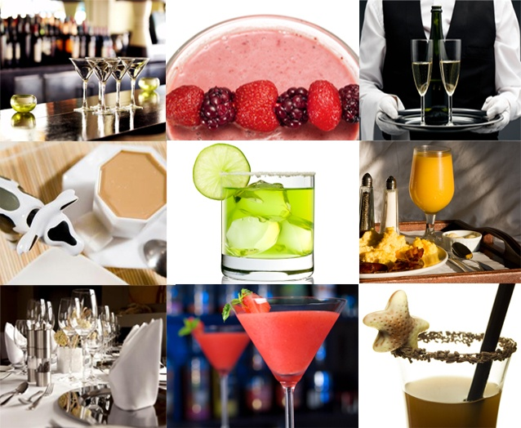



Operate a bar facility

D1.HBS.CL5.04

Trainee Manual




Project Base
William Angliss Institute of TAFE
555 La Trobe Street
Melbourne 3000 Victoria
Telephone: | (03) 9606 2111
Facsimile: | (03) 9670 1330
Acknowledgements
Project Director: | Wayne Crosbie
Chief Writer: | Alan Hickman
Subject Writer: | Alan Hickman
Project Manager: | Alan Maguire
Editor: | Jim Irwin
DTP/Production: | Daniel Chee, Mai Vu, Kaly Quach

The Association of Southeast Asian Nations (ASEAN) was established on 8 August 1967. The Member States of the Association are Brunei Darussalam, Cambodia, Indonesia, Lao PDR, Malaysia, Myanmar, Philippines, Singapore, Thailand and Viet Nam.
The ASEAN Secretariat is based in Jakarta, Indonesia.
General Information on ASEAN appears online at the ASEAN Website: www.asean.org.
All text is produced by William Angliss Institute of TAFE for the ASEAN Project on “Toolbox Development for Front Office, Food and Beverage Services and Food Production Divisions”.
This publication is supported by the Australian Government’s aid program through the ASEAN-Australia Development Cooperation Program Phase II (AADCP II).
Copyright: Association of Southeast Asian Nations (ASEAN) 2013.
All rights reserved.
Disclaimer
Every effort has been made to ensure that this publication is free from errors or omissions. However, you should conduct your own enquiries and seek professional advice before relying on any fact, statement or matter contained in this book. The ASEAN Secretariat and William Angliss Institute of TAFE are not responsible for any injury, loss or damage as a result of material included or omitted from this course. Information in this module is current at the time of publication. Time of publication is indicated in the date stamp at the bottom of each page.
Some images appearing in this resource have been purchased from stock photography suppliers Shutterstock and iStockphoto and other third party copyright owners and as such are non-transferable and non-exclusive. Clip arts, font images and illustrations used are from the Microsoft Office Clip Art and Media Library. Some images have been provided by and are the property of William Angliss Institute.
Additional images have been sourced from Flickr and SXC and are used under Creative Commons licence: http://creativecommons.org/licenses/by/2.0/deed.en

File name: TM_Operate_a_bar_facility_refined





Table of contents
Introduction to trainee manual 1
Unit descriptor 3
Assessment matrix 5
Glossary 7
Element 1: Prepare bar for service 9
Element 2: Take drink orders 29
Element 3: Prepare and serve drinks 37
Element 4: Close down bar operations 65
Presentation of written work 75
Recommended reading 77
Trainee evaluation sheet 79
Trainee self-assessment checklist 81

Introduction to trainee manual

To the Trainee
Congratulations on joining this course. This Trainee Manual is one part of a ‘toolbox’ which is a resource provided to trainees, trainers and assessors to help you become competent in various areas of your work.
The ‘toolbox’ consists of three elements:
- A Trainee Manual for you to read and study at home or in class
- A Trainer Guide with Power Point slides to help your Trainer explain the content of the training material and provide class activities to help with practice
- An Assessment Manual which provides your Assessor with oral and written questions and other assessment tasks to establish whether or not you have achieved competency.
The first thing you may notice is that this training program and the information you find in the Trainee Manual seems different to the textbooks you have used previously. This is because the method of instruction and examination is different. The method used is called Competency based training (CBT) and Competency based assessment (CBA). CBT and CBA is the training and assessment system chosen by ASEAN (Association of South-East Asian Nations) to train people to work in the tourism and hospitality industry throughout all the ASEAN member states.
What is the CBT and CBA system and why has it been adopted by ASEAN?
CBT is a way of training that concentrates on what a worker can do or is required to do at work. The aim is of the training is to enable trainees to perform tasks and duties at a standard expected by employers. CBT seeks to develop the skills, knowledge and attitudes (or recognise the ones the trainee already possesses) to achieve the required competency standard. ASEAN has adopted the CBT/CBA training system as it is able to produce the type of worker that industry is looking for and this therefore increases trainees’ chances of obtaining employment.
CBA involves collecting evidence and making a judgement of the extent to which a worker can perform his/her duties at the required competency standard. Where a trainee can already demonstrate a degree of competency, either due to prior training or work experience, a process of ‘Recognition of Prior Learning’ (RPL) is available to trainees to recognise this. Please speak to your trainer about RPL if you think this applies to you.
What is a competency standard?
Competency standards are descriptions of the skills and knowledge required to perform a task or activity at the level of a required standard.
242 competency standards for the tourism and hospitality industries throughout the ASEAN region have been developed to cover all the knowledge, skills and attitudes required to work in the following occupational areas:
- Housekeeping
- Food Production
- Food and Beverage Service
- Front Office
- Travel Agencies
- Tour Operations.
All of these competency standards are available for you to look at. In fact you will find a summary of each one at the beginning of each Trainee Manual under the heading ‘Unit Descriptor’. The unit descriptor describes the content of the unit you will be studying in the Trainee Manual and provides a table of contents which are divided up into ‘Elements’ and ‘Performance Criteria”. An element is a description of one aspect of what has to be achieved in the workplace. The ‘Performance Criteria’ below each element details the level of performance that needs to be demonstrated to be declared competent.
There are other components of the competency standard:
- Unit Title: statement about what is to be done in the workplace
- Unit Number: unique number identifying the particular competency
- Nominal hours: number of classroom or practical hours usually needed to complete the competency. We call them ‘nominal’ hours because they can vary e.g. sometimes it will take an individual less time to complete a unit of competency because he/she has prior knowledge or work experience in that area.
The final heading you will see before you start reading the Trainee Manual is the ‘Assessment Matrix’. Competency based assessment requires trainees to be assessed in at least 2 – 3 different ways, one of which must be practical. This section outlines three ways assessment can be carried out and includes work projects, written questions and oral questions. The matrix is designed to show you which performance criteria will be assessed and how they will be assessed. Your trainer and/or assessor may also use other assessment methods including ‘Observation Checklist’ and ‘Third Party Statement’. An observation checklist is a way of recording how you perform at work and a third party statement is a statement by a supervisor or employer about the degree of competence they believe you have achieved. This can be based on observing your workplace performance, inspecting your work or gaining feedback from fellow workers.
Your trainer and/or assessor may use other methods to assess you such as:
- Journals
- Oral presentations
- Role plays
- Log books
- Group projects
- Practical demonstrations.
Remember your trainer is there to help you succeed and become competent. Please feel free to ask him or her for more explanation of what you have just read and of what is expected from you and best wishes for your future studies and future career in tourism and hospitality.

Unit descriptor
Operate a bar facility
This unit deals with the skills and knowledge required to Operate a bar facility in a range of settings within the hotel and travel industries workplace context.
Unit Code:
D1.HBS.CL5.04
Nominal Hours:
40 hours

Element 1: Prepare bar for service
Performance Criteria
1.1 Set up bar display and work area in accordance with enterprise requirements
1.2 Check and restock bar products and materials where necessary in accordance with enterprise requirements
1.3 Ensure service equipment is clean, operational and ready for use
1.4 Store items in the correct place at the correct temperature
1.5 Prepare and stock a suitable range of garnishes and accompaniments

Element 2: Take drink orders
Performance Criteria
2.1 Receive customer orders
2.2 Check product or brand preferences with customer in a courteous manner
2.3 Provide clear and helpful recommendations or information to customers on selection of drinks if required

Element 3: Prepare and serve drinks
Performance Criteria
3.1 Greet customers in a polite, friendly and helpful manner
3.2 Prepare drinks in accordance with legal and enterprise standards using the correct equipment, ingredients and measures
3.3 Serve drinks promptly and courteously
3.4 Handle and use industry standard glassware and use garnishes and accompaniments appropriately
3.5 Minimise spillage and wastage and attend to accidents during service promptly and safely
3.6 Seek assistance from appropriate people for situations which pose a threat to safety or security of colleagues, customers or property
3.7 Seek feedback from customers in order to identify and implement improvements to beverage quality and take appropriate corrective action, if required
3.8 Deal with unexpected situations in accordance with enterprise procedures

Element 4: Close down bar operations
Performance Criteria
4.1 Turn off equipment in accordance with enterprise safety procedures and manufacturer’s instructions
4.2 Clear, clean or dismantle bar areas in accordance with enterprise procedures
4.3 Store garnishes and accompaniments, correctly
4.4 Set up bar for next service
4.5 Handover bar, where appropriate, to incoming bar staff

Assessment matrix
Showing mapping of Performance Criteria against Work Projects, Written Questions and Oral Questions
The Assessment Matrix indicates three of the most common assessment activities your Assessor may use to assess your understanding of the content of this manual and your performance - Work Projects, Written Questions and Oral Questions. It also indicates where you can find the subject content related to these assessment activities in the Trainee Manual (i.e. under which element or performance criteria). As explained in the Introduction, however, the assessors are free to choose which assessment activities are most suitable to best capture evidence of competency as they deem appropriate for individual students.
 |  |  | Work Projects | Written Questions | Oral Questions
Element 1: Prepare bar for service
1.1 | Set up bar display and work area in accordance with enterprise requirements |  | 1.1 | 1, 2 | 1
1.2 | Check and restock bar products and materials where necessary in accordance with enterprise requirements |  | 1.1 | 3, 4 | 2
1.3 | Ensure service equipment is clean, operational and ready for use |  | 1.1 | 5, 6 | 3
1.4 | Store items in the correct place at the correct temperature |  | 1.1 | 7, 8 | 4
1.5 | Prepare and stock a suitable range of garnishes and accompaniments |  | 1.1 | 9, 10 | 5
Element 2: Take drink orders
2.1 |  | Receive customer orders | 2.1 | 11, 12 | 6
2.2 |  | Check product or brand preferences with customer in a courteous manner | 2.1 | 13 | 7
2.3 |  | Provide clear and helpful recommendations or information to customers on selection of drinks if required | 2.1 | 14, 15 | 8
Element 3: Prepare and serve drinks
3.1 | Greet customers in a polite, friendly and helpful manner |  | 3.1 | 16 | 9
3.2 | Prepare drinks in accordance with legal and enterprise standards using the correct equipment, ingredients and measures |  | 3.1 | 17, 18, 19, 20 | 10
3.3 | Serve drinks promptly and courteously |  | 3.1 | 21 | 11
3.4 | Handle and use industry standard glassware and use garnishes and accompaniments appropriately |  | 3.1 | 22, 23, 24, 25, 26 | 12
3.5 | Minimise spillage and wastage and attend to accidents during service promptly and safely |  | 3.1 | 27, 28 | 13
3.6 | Seek assistance from appropriate people for situations which pose a threat to safety or security of colleagues, customers or property |  | 3.2 | 29, 30, 31 | 14
3.7 | Seek feedback from customers in order to identify and implement improvements to beverage quality and take appropriate corrective action, if required |  | 3.1 | 32, 33 | 15
3.8 | Deal with unexpected situations in accordance with enterprise procedures |  | 3.2 | 34, 35 | 16
Element 4: Close down bar operations
4.1 | Turn off equipment in accordance with enterprise safety procedures and manufacturer’s instructions |  | 4.1 | 36 | 17
4.2 | Clear, clean or dismantle bar areas in accordance with enterprise procedures |  | 4.1 | 37 | 18
4.3 | Store garnishes and accompaniments, correctly |  | 4.1 | 38 | 19
4.4 | Set up bar for next service |  | 4.1 | 39 | 20
4.5 | Handover bar, where appropriate, to incoming bar staff |  | 4.2 | 40 | 21

Glossary
Term | Explanation
Aerated waters | Carbonated non alcoholic beverage such as cola
BAC | Blood Alcohol Concentration: amount of alcohol in person’s bloodstream/system
Brixing | Ratio of syrup to water in a post mix system
CD | Compact Disc
Call brand | The brand of spirit a customer orders or calls for
Closing procedures | Generic term used to describe the tasks required to close a bar at the end of service
Comp drinks | Complimentary drinks; free drinks
Denaturing agent | Chemical placed into drip trays to prevent drips being re-used
Draught beer | Beer from kegs. Beer ‘on tap’ also known as bulk beer to differentiate it from packaged beer
Drip tray | Item placed under equipment to catch drips
Dry till | Bar where drinks are served but no money changes hands
Duty of Care | Obligation imposed on venues to look after the safety and welfare of people (staff and customers) when they are on the premises
EMP | Emergency Management Plan
FIFO | Fist In First Out method of stock rotation
Half nip | Measure of 15 ml
Inter-departmental transfer sheet | Internal form used to record movement of stock between different departments
Ml | Millilitres (30 ml = 1 ounce)
Mocktail | Non-alcoholic cocktail
Neat | Spirits served without anything
Nip | Measure of 30 ml
Opening procedures | Generic term used to describe the tasks required to set up a bar for service
Oxidised wine | Wine which has been exposed to air, causing it to become unpalatable over time
PA | Public Address
POS | Point Of Sale
Packaged beer | Bottles and cans of beer (as opposed to ‘draught’ beer)
Par bar | Maximum number of items (bottles/cans) in a bar when fully stocked
Pour brand | Brand of spirit used and poured if customer does not specify a brand
Post mix | Bulk system for dispensing aerated waters
RSA | Responsible Service of Alcohol
Requisition | Internal forms used to order stock for the bar
Stock sheets | Internals forms used to record stock
Sour mix | Mixture of lemon juice and sour mix: used in some cocktails
Sugar syrup | Also called ‘Gomme syrup’: mixture of sugar and water used in the making of some cocktails
Swab | Cloth used to clean
Ullages book | Book used to record waste
Waiter’s friend | Hand-held corkscrew containing a blade to cut and remove foil from the neck of wine bottles and a corkscrew and lever to remove the corks

Element 1:
Prepare bar for service

1.1 Set up bar display and work area in accordance with enterprise requirements

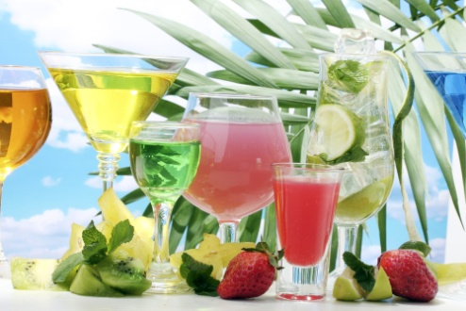
Introduction
Before work starts in a bar it needs to be set up for trade.
This Section identifies important set up work to be covered as part of this process.

Context for this Unit
This unit describes the performance outcomes, skills and knowledge required to carry out bar operations in a range of hospitality enterprises. It reflects the role of a bar attendant and applies to bar operations in all hospitality sectors, including all types of bars.
It relates to the service of a range of alcoholic and non-alcoholic beverages commonly found in a bar.
Different countries will have various legislative requirements in relation to service of alcohol.

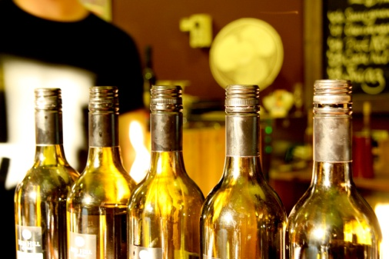
Need to set up the bar
Bars need to be properly set up prior to service for two important reasons:
- To ensure the bar is fully ready to provide service to customers when they arrive – everything must be ready, everything needs to be in place. You have to give the impression you were ready for the customers and had prepared for their arrival
- To make sure the bar looks appealing to customers – there is a need for the area to be neat and tidy and for staff to be able to focus on customer service when they place an order, rather than spend/waste time doing tasks which should have been done prior to opening.

Types of bars to which this unit applies
This unit applies to the operation of all bar types including:
- Permanent bars – bars which are ‘in place’ all the time
- Temporary bars – bars which are established for short-term reasons such as parties, special events, or to cater for especially high levels of trade
- Dry till bars – see below: a bar where drinks are served but no money changes hands.

What is involved in bar service?
Understanding what a bar does is useful as it gives a context and focus for the set up duties which need to be performed.
In general terms, bar service will include the preparation and service of a range of drinks including:
- A variety of mixed drinks – which may be served in short (capacity approx. 140 ml) or long glasses (capacity approx. 200 ml) and served using either a full nip of spirits (30 ml) and/or a half nip (15 ml) nips
- A range of cocktails – some bars promote cocktails more than others. Some bars have a limited range of house cocktails while others boast a comprehensive range
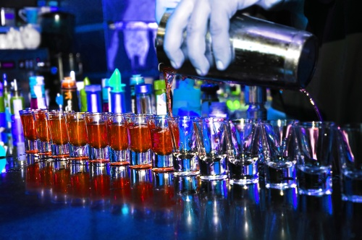
- Beers – draught and packaged. Draught beer comes from kegs/barrels and is the beer ‘on tap’ – packaged beer refers to all the beer available in bottles, stubbies and cans. Not all bars have ‘draught’ beer
- Spirits – these may be:
- ‘Neat’ - served on their own with nothing added
- ‘On ice’ – served only with ice: also known as ‘on the rocks’
- Mixed with aerated waters (such as cola, lemonade, dry ginger, lemon squash) or juices
- Liqueurs – these are usually served on their own (a serve size is 28 ml – 30 ml) but may be served over ice, mixed into a cocktail or in some cases added to coffee
- Wines – still table wines and sparkling wines (red and white)
- Non-alcoholic beverages – fruit juices, still and sparkling waters and aerated waters/soft drink: aerated waters may be dispensed from bottles, cans or post mix
- Fortified drinks – which include sherry, port, muscat, tokay and frontignac. A standard serve size for a fortified wine is 60 ml.

Enterprise requirements
Enterprise requirements and standards will apply to the set up of a bar and the following requirements may apply – set up:
- Must support and reflect the style of service being offered
- Needs to accommodate and embrace the equipment being used
- Will vary with the size and layout of the bar
- Will vary depending on staff numbers working in the bar and helping with set up tasks
- Must comply with required food safety requirements.

Opening procedures
‘Opening procedures’ is a generic term used to describe the tasks needed to set up/prepare a bar for service.
Opening procedures will vary between establishments and will vary between bars in the same business.
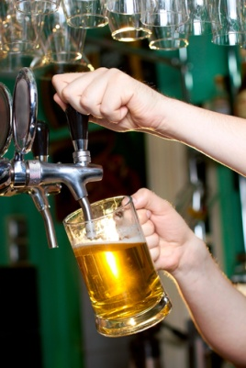
Opening procedures may include:
- Connecting the draught beer – where bulk beer is served you may be required to:
- Turning on instantaneous beverage chillers
- Drawing beer through to taps and testing/examining for quality
- Turning on espresso coffee machine
- Setting out drip trays – with de-naturing agent – under beer fonts
- Setting out trays and racks – ready to hold dirty glassware
- Checking stock levels of all beverage items – where any beverage item is ‘out of stock’, other staff should be notified of this and effort made to order/obtain what is required
- Collecting clean cloths/swabs, tea towels and bar runners
- Laying out bar runners, coasters, tent cards, promotional materials and other items as required
- Setting ashtrays in smoking areas
- Checking equipment and bar utensils are clean and in working order – this check should include all operational bar equipment (such as refrigeration, beer taps, blenders, ice machines, ice crushers) as well as all ancillary items such as lighting, air conditioning, music systems, vending machines, advertising signage
- Placing racks of clean glassware out into their service positions – this requires glasses to be placed into a glass chiller which will also need to be turned on
- Checking glassware – to ensure they have no cracks, chips, lipstick marks: all glasses must look clean
- Placing spirit pourers on the appropriate bottles – ensuring sufficient supply of liquor
- Preparing garnishes – most bars prepare standard garnishes such as lemon and orange slices, and lime quarters: where a strong demand for cocktails exists there will be a greater demand for a bigger range of garnishes (cherries, cucumber, orange wheels, pineapples) plus the likelihood of a need to prepare sugar syrup, sour mix, and fresh juices
- Checking bar displays and all promotional material – refilling as required
- Re-stocking accessories for cocktails – straws, decorations, glassware
- Stacking and ensuring cleanliness of service trays
- Filling up ice buckets/tubs
- Collecting cash drawer and placing in cash register – checking or replacing register journal.

Additional pre-service considerations

Dry till, tab or account
Most bars, with the exception of those operating within an accommodation venue, will trade on a cash basis.
Some bars will also have credit card and electronic fund transfer facilities.
However, from time-to-time the bar may run a ‘dry till’, a ‘tab’ or an account for a customer.
This can be used (sometimes only with prior arrangement and approval from management) where a group or party wishes drinks to be served to them without the need for payment every time they receive a drink.
When you run a dry till, tab or account, the selling prices of all the drinks served are rung up (or otherwise recorded) behind the bar, and the bill is then paid by the appropriate person (such as the person organising an event, or the host of a small party): in some cases, the account is pre-paid.
On some occasions, the person paying the account sets a pre-determined dollar amount up to which they will pay. It is usual to notify this person shortly before this amount is reached, as they sometimes extend the amount they have agreed to spend.
Otherwise, when the set amount has been reached, people start paying for their own drinks.
There may be limitations on what people can order when a dry till is being used – for example, customers may only be able to have draught beer, soft drink and house wine: if guests want to drink spirits or bottles of wine they have to pay for their own drinks.

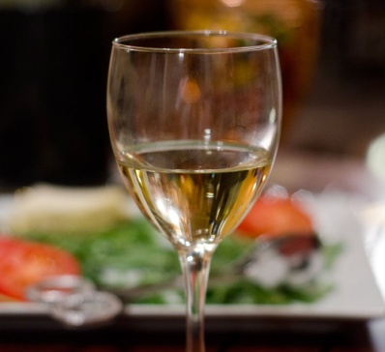
Inclusive packages
In some bars on some occasions – regularly or rarely – staff will be expected to deal with ‘inclusive packages’ situations.
This may be where a busload of patrons arrives for a meal and the arrangement is they are entitled to one or more prescribed drinks as part of the package.
There are usually limits about what sort of drinks can be dispensed for these packages: the arrangement may only include house wine, draught beer and soft drinks.
In other circumstances, patrons may only be allowed one set drink, or one drink from a restricted drink list.
Check with management to see if patrons are allowed to up-grade their drinks if they pay the difference: also check to see if any additional 'special' limitations or extras apply.
In some other cases, people on a package will not receive any free or inclusive drinks, but are eligible for a set discount across a range of drinks.
In package deal situations it is critical to ensure:
- Only people eligible for the package deal receive drinks
- Patrons only receive the number of drinks they are entitled to
- Patrons only receive the type of drinks covered by the deal.

Pre-set drinks
On special occasions – the exact nature of these occasions is limitless but it is common – a group, business or individual may arrange a mini-function where they pay for a set amount of specified beverages.
In such a scenario the guests may arrive at a given time, and receive one or several drinks from a prescribed list – examples include a sherry, a glass of sparkling wine, a set cocktail.
If patrons want anything else, they have to pay for it themselves.
Beware: you will have to apply excellent customer service skills with patrons who have to be told their favourite drink has not been included on the 'free list'!

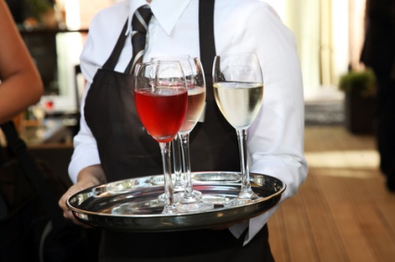
Open bar
The term ‘open bar’ is used for functions where there is no limit on the type of drink guests can order.
Whereas many/most functions will have some sort of limitation on what guests can have 'free of charge' an open bar means there are no such restrictions.
Note: despite the above definition, there are variations on a theme – at some venues an open bar will include bottled premium products and wine whereas other venues will exclude these from their definition of an open bar.
You will need to check with your supervisor.

1.2 Check and restock bar products and materials where necessary in accordance with enterprise requirements

Introduction
An important part of setting up a bar is to ensure all the required products and materials are available and ready to use.
This Section identifies items which need to be checked, possible enterprise requirements and what to do if things are not as they are supposed to be.

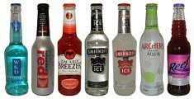
Products and materials to check
The exact nature and type of products and materials to check will depend on the individual bar where you are working.
Some bars have very basic requirements and others have extensive requirements.

All types of drinks
You need to check:
- Alcoholic beverages – beers, wines, spirits, liqueurs
- Non-alcoholic beverages – aerated waters, fruit juices, milk, cream.
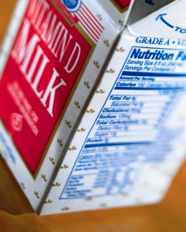
Checks must ensure:
- Sufficient quantities of all items to meet expected trade
- Juices, milk and cream have not exceeded their ‘best before’ or ‘use by’ dates
- Stock is readily accessible
- Back-up supplies are available.

Garnishes
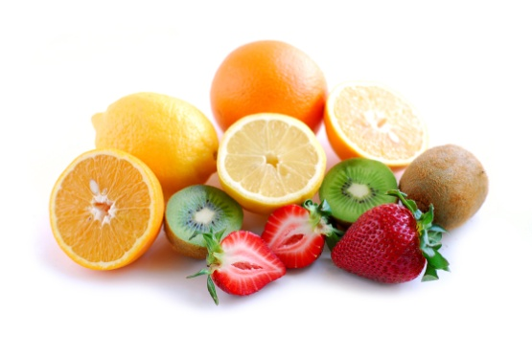
You need to check:
- The garnishes commonly required by the bar are prepared and available – these will include basics such as slices of lemon and slices of orange
- Ingredients are available to enable preparation of extra and/or other garnishes as possibly needed by the type of drinks offered on the drink list.
See Section 1.5 for detail on preparing garnishes.

Cleaning equipment
You need to check:
- Equipment and service counters are clean and ready for service
- All equipment used in the preparation and service of drinks is clean
- Cleaning materials (chemicals, cleaning agents and cleaning tools and cloths) are available and ready to use if needed during trade.

Refrigeration equipment
You need to check:
- All refrigeration units are turned on
- Items are operating at the required temperature:
- Units containing food (milk, cream, fruit) should operate at 5°C or below
- Drink units may have a nominated temperature for different types of drinks – such as 2°C for beer fridges.

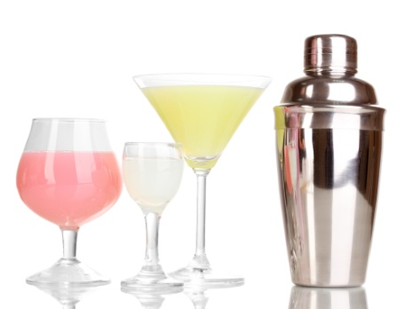
Utensils and equipment
You need to check:
- All required utensils are available – items may include:
- Chopping/cutting boards and knives
- Bar spoons to stir drinks
- Cocktail shakers
- All required equipment is available – items may include:
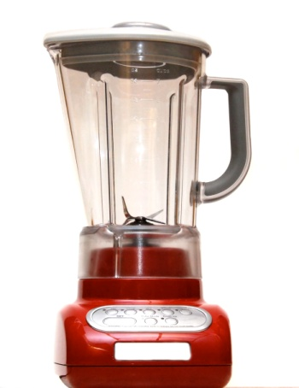
- Blenders
- Ice crushers
- Glass chillers
- Utensils and equipment are safe to use
- Items are clean
- Sufficient utensils and equipment are available
- Items are laid out in their correct location.

Cloths and towels
You need to check:
- All required linen is available – such as bar runners/towels, swabs, tea towels, cloths
- Items have been washed and are clean
- Sufficient quantities are available
- Items look appealing – not torn, tired or shabby.

Display items
You need to check:
- Advertising and promotional materials are available – these may include:
- Tent cards
- Menus
- Drink lists
- Book matches
- Signage and posters
- Sample products located strategically to encourage sales
- Special displays have been created as required – these may include:
- Displays to support a theme
- Displays for a special event/party
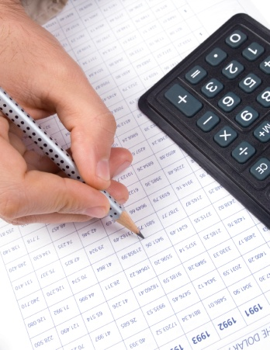
- Displays in a dining area to promote wine.

Enterprise requirements
Enterprise requirements relating to re-stocking bar products may include:
- Only the supervisor may be authorised to order stock
- A requisition must be used to order all stock
- Stock can only be ordered to re-stock the bar to a nominated par level
- An inter-departmental transfer form must be completed if stock is taken from another bar or department
- All stock delivered to a bar must be immediately secured and stored behind the bar or under refrigeration (as appropriate)
- New stock delivered to the bar must be rotated using the FIFO method – meaning new stock is placed behind old stock.

Action to take if items are not available or things are not correct
You may need to:
- Advise your supervisor – tell them of your concern and they will take the necessary action
- Order necessary items (materials, ingredients, utensils, equipment, linen)
- Undertake cleaning which has not been properly done
- Put away deliveries to the bar which have arrived
- Create (or replenish or tidy) displays.

1.3 Ensure service equipment is clean, operational and ready for use

Introduction
Service equipment must be clean, operational and ready for use when the bar opens for business.
This Section identifies service equipment which may need to be checked, how to check items and presents general hygiene requirements for bars.

Service equipment
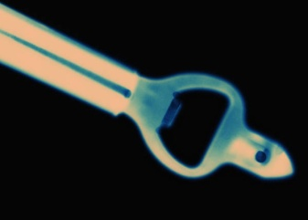
Service equipment will vary between bars but can include:
- Bottle openers – which may be hand-held or counter-mounted: check they are clean, safe and operational
- Corkscrews – these may be hand-held (‘waiter’s friend’) or counter-mounted units: check they are clean and safe to use
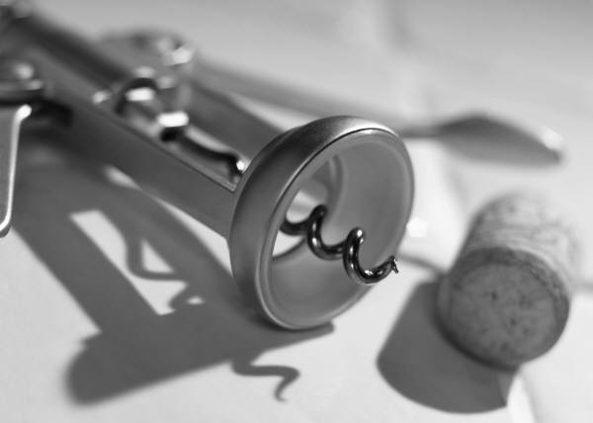
- Measures – these are items used to dispense controlled volumes of liquor. They include:
- Egg cup measures – double-ended items into which liquor (usually spirits) are poured to measure quantity dispensed
- Egg cup measures are usually 30 ml (at one end) and 15 ml at the other, but are also in 30 ml and 60 ml varieties
- Optics – these are inserted into the necks of bottles (usually spirits) to measure the volume of liquor dispensed
- Common sizes for optics are 15 ml and 30 ml
Check to ensure they are clean, not leaking and fitted to all spirits commonly used behind the bar.
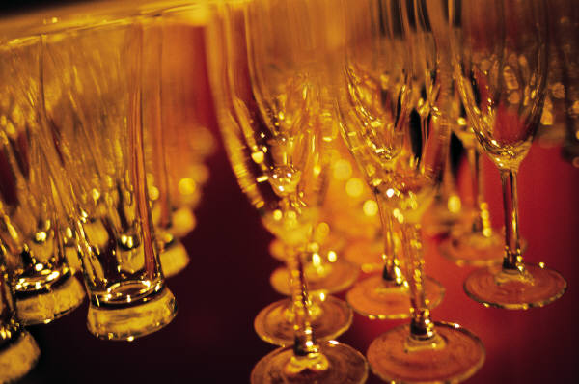
- Glassware – glassware includes glasses and jugs. Jugs are used to serve water, contain bulk quantities of fruit juice, sour mix, or other liquids. Alcoholic beverages may also be served in jugs. Glasses refer to all the types of glasses used by the venue to serve the drinks they offer for sale. See ‘Glassware’ below for information on specific types of glasses, what they are used for and their volume. Check to ensure all glassware is clean and undamaged (no cracks or chips)
- Knives and chopping boards – these are required to cut and peel fruit. Check they are clean, safe to use and sufficient in quantity to address expected level of trade
- Ice containers – you may be required to work with:
- Containers of ice behind the bar for use when adding ice to drinks
- Ice buckets – used when serving bottles of white wine and sparkling wine to customers. Make sure ice containers behind the bar are full and clean. Make sure ice buckets are clean, look attractive and are readily accessible
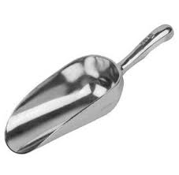
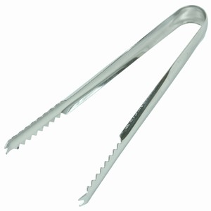
- Tongs and scoops – tongs are used to lift/place pieces of fruit or ice into drinks to avoid having to handle fruit/ice with the bare hands. Scoops are used for retrieving ice from ice making machines and ice containers. A glass must never be used to remove ice from an ice machine or ice container as it can easily break causing bits of glass to mix with the ice presenting a serious hazard to customers. Check tongs and scoops are located where they should be, are clean and sufficient in number. Coasters – these are an effective way to promote drinks, cocktails and the venue. You will need to place them on the bar, service counters and tables as part of opening procedures. It is an industry standard ‘used’ coasters are never re-used as they look unclean
- Bar mats – these are towels/runners placed on the bar to enhance presentation and absorb spills from drinks. Make sure they are clean and presentable, and placed to cover the required bar counter areas
- Refrigeration equipment – includes under-counter storage units and glass-fronted display units. Check to ensure they are clean and attractive (no dirt or marks), fully stocked, and working as required (at the correct temperature)
- Post mix – these unis provide bulk aerated waters at point of service. Check to ensure:
- All flavours are working/providing drink as required – that is, carbonation is correct and the strength of the product is correct
- Temperature is correct
- Sufficient syrup available
- The unit is clean and attractive
- Beer dispensers – where bulk bee is used, you need to check to ensure:
- Beer is coming through every beer tap/beer line to be used
- Temperature is correct
- Taps are operating correctly – turning ‘on’ and ‘off’ properly
- Drip trays are in position – and have de-naturing agent in them
- Service trays – where drinks are served to tables, there will be a need to ensure drink service trays are ready. Check to ensure:
- They are clean
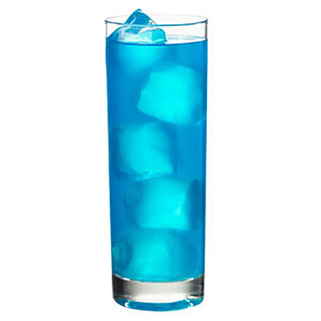
- There is sufficient number
- Anti-slip mats are fitted (if used by the venue).

Glassware
Beverages can be served in a variety of glasses. The following types are the most commonly used:
- Highball glass – a long, straight-sided glass holding 200 – 300 ml and used for cocktails such as Harvey Wallbanger, Collins and Tequila Sunrise. The Highball is also a popular glass for serving fruit juice, soft drinks and long, mixed drinks
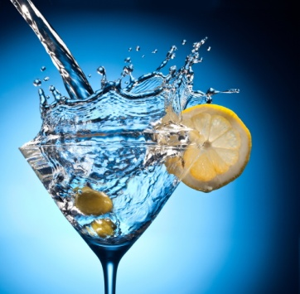
- Pilsener – a beer glass (200 ml upwards in size). Mugs/handles are also used
- Martini glass – the most well-known cocktail glass, featuring a classic V-shape (approximately 90s ml capacity) used for Martinis and other small volume cocktails
- Manhattan glass – a larger version (180 – 200 ml) of the Martini glass used by many as their generic cocktail glass
- Old fashioned glass – a squat glass (short and wide) of approximately 200 ml used for cocktails such as a Black Russian. Also commonly used to serve neat spirits, spirits served on-the-rocks, and short mixed drinks

- Colada glass – curvy glass of 300 – 400 ml capacity used for cocktails such as Coladas, Fluffy Duck and Mai Tai
- Champagne flute – a purpose-built glass used to serve Champagne and a range of Champagne cocktails. Capacity varies between 160 ml – 200 ml
- Brandy balloon – a short-stemmed, large-bowled glass used to serve straight Cognac as well as Brandy Blazers, White Russian and other cocktails. This style of glassware comes in a very wide selection of sizes from 200 ml to 4 litres. The really large ones are used for display purposes, not for the presentation or service of drinks
- Test tube – test tube-shaped glasses (holding approximately 60 ml) commonly housed in a wooden or metal rack. Can be used as the glass for service of drinks, or (to enhance showmanship) as the vessel from which ingredients are poured into a glass when making a cocktail. Some venues do not use these glasses as they believe they encourage irresponsible consumption of alcohol
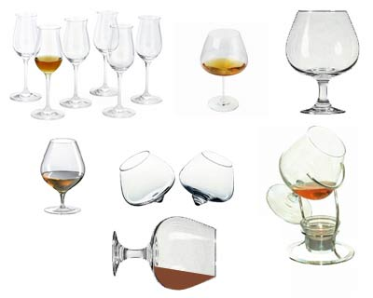
- Liqueur glass – a small glass (28 – 30 ml) used to serve a straight liqueur or a liqueur with cream floated on top
- Shot glass – small glass (45 – 60 ml) used for Shooter recipes and for serving single shots. Some venues do not use these glasses as they believe they encourage irresponsible consumption of alcohol.
The choice of glass will be dictated by:
- House policy – such as the designated glass as listed in a house recipe. For example, the venue may use Manhattan glasses (or some other generic glass) for the majority of its cocktails
- Tradition – certain cocktails are traditionally served in certain glasses: cocktail books and house recipes will specify what is required.

Cleaning glassware
To achieve clean glasses, standard industry practice is to:
- Wash glasses after every use by hand or in a glass washing machine, ensuring:
- Water used is a minimum temperature of 70˚C
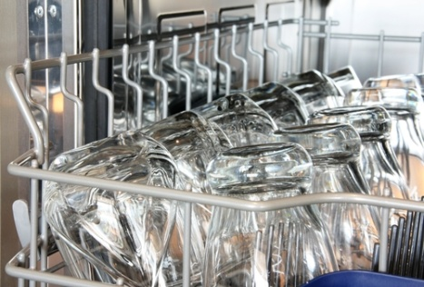
- Appropriate detergent is used and diluted according to manufacturer’s instructions, as or if required
- Store glasses correctly. Clean glasses must be stored so they do not become re-contaminated.
All glasses must be inspected before use to check they are clean and suitable for use.
Websites on glassware
Take time to visit the following to gain an understanding of the glasses available and the names for the different glasses:
- http://www.spiritdrinks.com/DrinksByGlass.asp
- http://www.nationalbartenders.com/ResGlassware.asp
- http://www.hospitalitywholesale.com.au/front-of-house/glassware/cocktail-glasses.html
- http://www.hostdirect.com.au/listProduct/Glassware/Cocktail+Glasses/.

How to check items
Making the necessary checks will include the following activities:
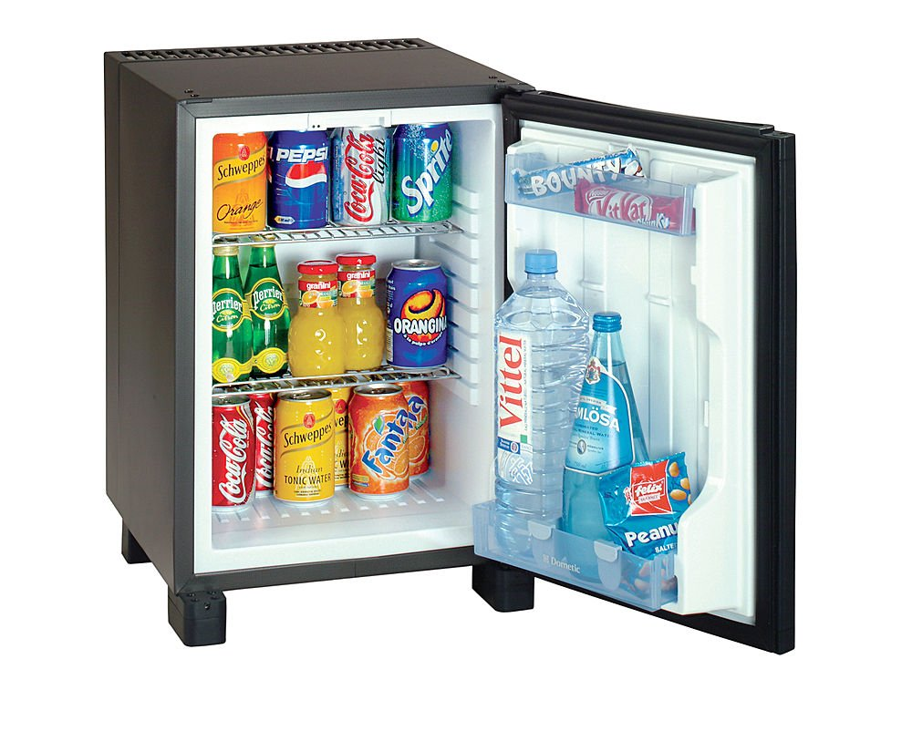
- Visually inspecting items – to ensure they look attractive/appealing and to check they are ‘in place’: see also Section 1.3
- Counting items to ensure there are ‘enough’ for the expected level of trade
- Verifying the temperature of:
- Refrigeration units – by reading their temperature
- Draught beer – by using a beer/food thermometer
- Testing items – to make sure they are working
- Inspecting areas and items – to ensure they are safe
- Tasting products – such as draught beer to ensure it has no ‘off flavours’.

General bar hygiene issues
Beverages are classified as food and all the requirements applicable to safe food handling also apply to beverages.
The following actions are the basic requirements for people who work behind a bar:
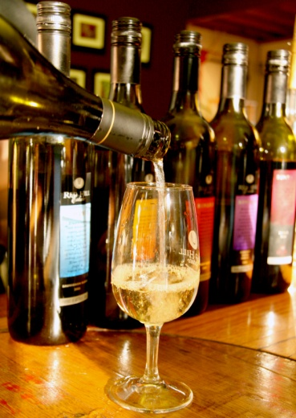
- Use a fresh glass for every drink – do not re-fill a previously used glass, as this may be a source of contamination to drinkers
- Handle glasses by the base or stem to avoid contamination of the glass by your fingers – do not touch glasses around the rim of the glass
- Use a fork or tongs when putting fruit or ice in a glass – do not use your fingers
- Do not re-use any fruit, straws, beverage, garnish left by a customer or which comes back from the tables – all waste must be thrown out
- Ensure drinking straws are correctly stored – they should be stored so they are kept free from flies, dust and contamination. They must be able to be obtained one at a time without the others being touched so it is not acceptable to store straws in a drinking glass on the bar counter
- Check glass washing machine has detergent, and is operating at the prescribed temperature (70˚C)
- Put de-naturing agent in drip trays – there must be sufficient de-naturing agent to actually de-nature the waste beer and stop the premises pouring this waste beer back into the barrel
- Do not re-use 'waste' beer (waste beer includes beer left by patrons or beer derived from flushing out the beer lines prior to ending trade for the day, or prior to cleaning them) – this includes beer returned from tables in glasses and jugs
- No smoking or spitting behind the bar
- Wash hands at all times kitchen-based food handlers are required to wash their hands – such as after handling chemicals, after using toilet, after handling rubbish
- Ensure you have clean clothes, hands and fingernails
- Stay away from work if ill or suffering from an infected cut: notify doctor of food handler status – bring a medical clearance stating fitness for work on return
- Do not substitute brands or water down any beverages
- Ensure all glassware and utensils are clean – plates and glasses must also be free of chips and cracks.

1.4 Store items in the correct place at the correct temperature

Introduction
In the same way foodstuffs must be stored under the right conditions, so too must bar products be correctly stored.
Some products are stored at room temperature, some are stored under refrigeration and some are stored in purpose-designed and built units.
This Section requirements and issues relating to the correct storage of bar items.

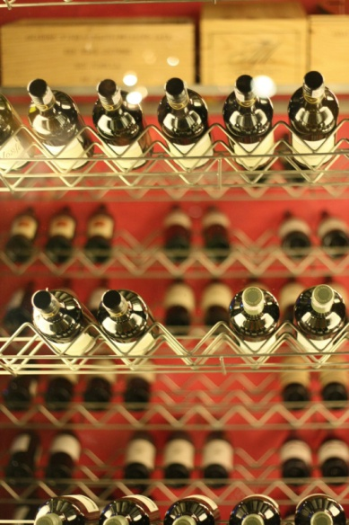
The basics of storage

Stock rotation
As mentioned stock should be rotated using the FIFO stock rotation method.
New stock must be placed behind existing stock – the existing stock must therefore be brought/moved forward.
Rotating stock in this way ensures:
- Warm stock is placed behind cold/refrigerated stock – meaning the customer will get a cold bottle/can rather than a warm one
- Stock is used in its correct sequence – helping to avoid out-of-date stock.
Note: some premises may buy certain red and white wines with a view to ‘laying them down’ for a number of years to age and grow in value.
These wines should be clearly identified and these wines will not be rotated on a FIFO basis.

Storage basics
Beverages must be stored in the right place, and at the right temperatures.
This may include keeping:
- Packaged beer in a cool storeroom or in a refrigerated coolroom – this is a requirement where the bar also doubles as a bottleshop and where bar staff are also required to sell products for take-away/consumption off the premises. Packaged beer for service in the bar should be kept in refrigerators at service temperature (1°C to 3°C)
- Beer kegs in a coolroom or cellar – for remote pull systems the recommended temperature range is 5°C to 10°C and for direct pull systems the recommended temperature range is -1°C to +1°C
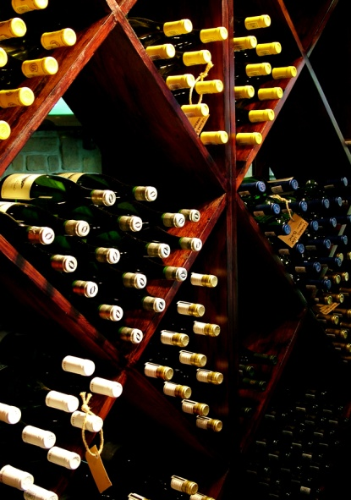
- Debate exists as to the optimum storage temperature for red wine – some will nominate a precise temperature (say, 15°C), others will nominate a temperature range (say, 14°C to 18°C), while others will indicate different reds should be stored at different temperatures depending on where they were made, the grapes used, and the vintage. This said, generally speaking, reds are kept at ‘room temperature’ in a room out of direct sunlight: red wine bottles should be stored lying in racks, on their sides, to keep any corks wet – this stops them drying out and allowing the wine to oxidise. Where the red wines are capped with a Stelvin seal (screw cap), it makes no difference whether the bottle is stored standing up or lying down because the seal is air-tight: tradition may require the venue stores Stelvin-capped wines lying down to fit their red wine display racks
- White wine is best kept stored in a cool storeroom or placed in a refrigeration unit until required. In practice this will usually mean they are stored at around 2°C to 3°C even though there may be very legitimate reasons for storing them at (slightly higher) temperatures, up to 10°C for some whites in order to enhance their flavour. Check the following sites for additional information about the storage temperatures for wine:
- http://www.vanlines.com/storage_guide/wine_storage.html
- http://ezinearticles.com/?Wine-Storage-Dos-And-Donts&id=1035984
- Dairy items (milk, cream) should be kept under refrigeration (below 4°C) at all times
- Juices can be stored in a cool storeroom and or in a refrigerator (below 4°C) until service
- Spirits and liqueurs are to be stored in a cool storeroom or on shelves in a bar: keep out of direct sunlight
- Fortified wines can be stored at room temperature but some establishments require their dry sherries (only) to be stored under refrigeration.

Storage options
Behind a bar the common storage options are:
- Refrigeration units – for beers, aerated waters, white wines, fruit and dairy products
- Storage cupboards – for general purposes items such as stationery, accompaniments (see next Section), swabs and towels, back-up supplies of stock, spare utensils and equipment.

Wine units
The growth in the popularity of varietal table wines, the increase in customer knowledge about them and higher levels of customer expectations has seen the need for many bars to offer premium bottled wines for sale by the glass.
This concept allows customers to enjoy just one glass of a top quality wine without having to buy (or drink) the entire bottle.
The ability of premises to offer such wines by the glass has resulted in the growth of a variety of wine dispensing units able to hold opened wine (at room temperature, or under more controlled conditions [temperature and humidity]), using nitrogen to replace air/oxygen in the bottle and avoid problems associated with oxidation.

Pest control
Standard pest control measures should be applied in a bar to control pests.
The three standard practices are:
- Build them out – this means:
- Blocking up holes where they can enter
- Fitting fly screens
- Chase them out – this means:
- Using sprays to get rid of flies, mosquitoes and other flying and crawling pets
- Using traps to catch mice and rats
- Starve them out – this means:
- Cleaning the bar area regularly and properly
- Not leaving food or water lying around to serve as a source of sustenance.

1.5 Prepare and stock a suitable range of garnishes and accompaniments

Introduction
Some bars will have very little in the way of garnishes and decorations, and some will have quite a deal.
This Section explains the need for, and identifies, garnishes and accompaniments.

Need for garnishes and accompaniments
Over time bars have evolved into places where some decorations, coasters, garnishes and/or accompaniments are required.
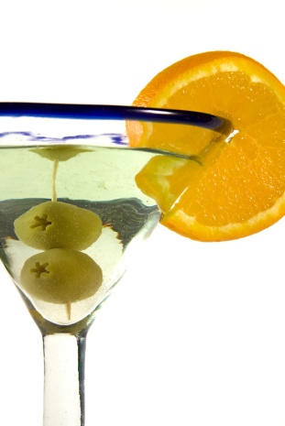
In many instances, these items are necessary:
- To meet customer expectations
- To meet competition
- To differentiate the establishment from the opposition.

Sample items
You may find the following ‘miscellaneous’ items behind a bar to enhance the presentation of drinks:
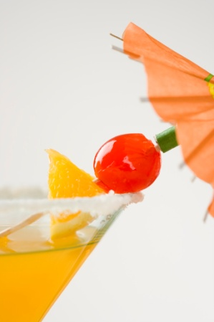
- Coasters – these can be placed on bar counters, tables, shelving, and served with individual drinks
- Decorations – there is a wide range of animal figures, umbrellas and the traditional mermaid
- Edible garnishes – usually lemon and orange slices, but can include almost anything where the bar serves an extensive variety of cocktails
- Non-edible garnishes – includes hollowed-out pineapples and coconut shells for eye-catching cocktails
- Drinking straws – these may be long or short, straight or flexible: they may also be individually wrapped or stored in a container to comply with health regulations.

Preparation
It is important for these items to be prepared as part of the set up procedure, and re-stocked in the same way that beverage products are ordered.

Garnishes
Garnishes should be prepared fresh for each service session.
Where your venue stores left-over garnishes from previous sessions, these should be used first, before freshly made ones.
After cutting and preparation, garnishes may be:
- Stored on a plate or saucer
- Placed into a plastic or stainless steel container
- Covered
- Refrigerated.
Garnishes should be prepared as shortly as possible before service as leftover ones look tired and unattractive.
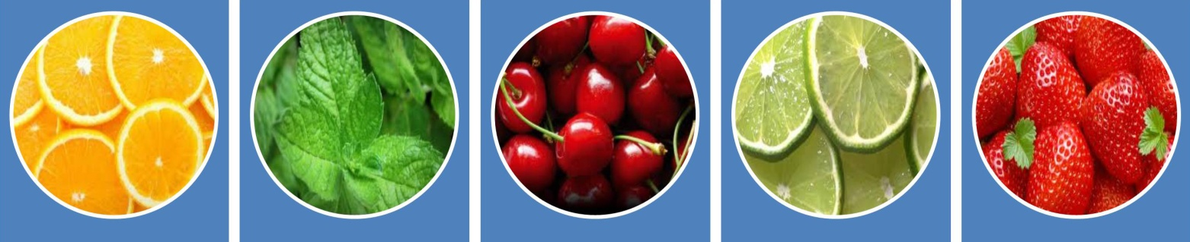
See Section 3.4 for more detail on garnishes.

Accompaniments
Preparing accompaniments involves:
- Checking they are available
- Re-stocking supplies of drinking straws
- Ensuring the containers they are supplied in are open and readily accessible
- Placing individual decorations/items into other containers ready for use.
Check out the following website for ideas about bar items and accompaniments available:
- http://barware.cart.net.au/cat/34725.html.

Work Projects
It is a requirement of this Unit you complete Work Projects as advised by your Trainer. You must submit documentation, suitable evidence or other relevant proof of completion of the project to your Trainer by the agreed date.
  - Identify a bar in a hospitality venue and prepare a written submission which details:
- Opening procedures for the bar
- Checking and re-stocking requirements for the bar
- Cleaning requirements as part of opening procedures
- Storing requirements for all alcoholic and non-alcoholic beverages and ingredients behind the bar
- Requirements for preparing beverage garnishes before service and storing them for use during service.

Summary

Prepare bar for service
When preparing bar for service:
Adhere to enterprise standards and requirements
Follow all nominated opening procedures
Be aware of the upcoming trading session and the requirements it is likely to create
Set up for the requirements of the individual session
Check and re-stock alcoholic and non-alcoholic beverages as required
Prepare garnishes as required
Check and replenish decorations as necessary
Ensure all items, equipment and utensils are clean
Check operational readiness of all equipment
Turn on refrigeration as required
Check/supply clothes, towels and other linen
Notify supervisor of problems or bar-related needs
Check and ready glassware
Apply all safe food handling protocols
Store and rotate stock correctly.

Element 2:
Take drink orders

2.1 Receive customer orders

Introduction
When customers place a drink order, either at the bar or at the table, they expect they will receive the drink they have ordered.
This necessitates you noting or memorising the order correctly.
Your employer also expects you to get the drink order right so you deliver high levels of customer service and to avoid wastage caused when the wrong drink is mixed, served and rejected by patrons.
This Section describes practices to ensure customer orders are correctly taken.

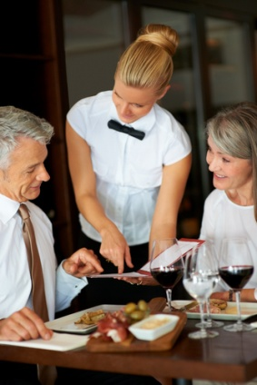
Greeting the customer
When taking a drink order, always greet all customers in a friendly manner.
See Section 3.1 for detail on how this is done.

Taking orders
Accuracy is important regardless of whether the order is written down or memorised.
If you are not sure of exactly what is being ordered, ask the customer to repeat it or clarify it.
You should repeat the order back to the customer to check you have heard the order correctly.
Behind a bar, it is preferable for service staff to memorise the order, whereas an order taken at a table may have to be noted down.

In some cases, the person taking the order might not be the same person who prepares or serves it so legibility and clarity are important for hand-written orders.
Many venues use a standard order form and may employ a range of house-specific abbreviations familiar to all staff – for example:
- OJ = orange juice
- DWW = Dry, white wine.

Make sure the order is clear
Lots of drink orders have the potential to be misinterpreted unless they are clearly explained.
For example, a customer may come to the bar and say ‘A beer thanks’ and be quite clear in their own mind about exactly what they are ordering, but they have nor stipulated:
- The brand they want
- The style of beer required
- Whether they want a can or glass
- The size they want.
The moral of this story is where there is room for confusion, ambiguity, options or alternatives, make sure you clarify the situation, for example:
- If they order “rum” do they want:
- Dark, white or other?
- Under- or over-proof?
- Imported or domestic?
- If they order a “glass of white wine, do they want
- Dry?
- Sweet?
If ever there is the possibility of a mix-up, you must always clarify the order.

Enterprise standards
There are lots of variations possible for many commonly ordered drinks so businesses usually have their own standards about how to interpret orders which may be unclear.
It would become very time consuming and repetitive to ask every customer to clarify orders such as ‘Brandy and dry’ – for example:
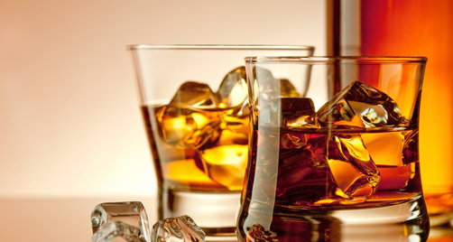
- Do they mean a full or half nip?
- Do they want it served in a short or long glass?
- Ice or no ice?

Full or half nip?
It is usual for bar staff to interpret an order for a spirit as a request for a full nip (30 ml).
This means if a customer orders a ‘Vodka and tonic’ you will serve them a 30 ml of vodka.
House rules may require you to ask the customer “Full or half?” but this can be time consuming and tedious.
Some premises will have house rules preventing you from serving double shots of spirits or liqueurs for responsible service of alcohol reasons – check with your supervisor.

Long or short glass?
If the customer does not specify whether or not they want a long or short glass, it is industry practice to make the drink in a long glass (one of approx. 200 ml capacity).
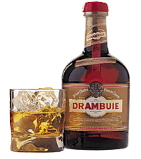
Once again, house rules may require you to ask “Long or short?”

Ice or no ice?
If the customer does not mention whether they want ice or not it is standard practice to add ice.
Note however any drink ordered ‘neat’ should not have ice added.
A spirit ordered ‘on the rocks’ means the customer wants it poured over ice – nothing else added: no water, no mixer or aerated water.
Note to any drink order ‘with water’ (such as ‘Scotch and water’) should not have the water added by bar staff: common practice is to pour the neat Scotch or other spirit into the glass and offer the water jug to the customer so they can add the amount of water they deem appropriate.

2.2 Check product or brand preferences with customer in a courteous manner

Introduction
There are many different products and brands available with more coming onto the market seemingly everyday.
It makes good sense and is excellent customer service to check with the guest regarding their preference if they have not specified what they want.
This Section presents information to assist in ensuring customers receive the drink they want.

Personal preference
Some people are devoted to a certain brand and simply will not want to drink anything else – if your bar does not stock their brand they will not drink a substitute.
People like this will usually switch drink type rather than drink an alternative brand.
Some people will prefer one brand but will be happy to drink something else understanding a bar cannot possible stock every brand of spirit available.
Other people consider price and prefer to drink a cheaper, domestic brand if one is available – they will appreciate you pointing this out to them.

Pour and Call brands
Behind the bar, most venues stock a ‘Pour’ brand, as well as several ‘Call’ brands, and you must know what these are in order to:
- Answer customer questions
- Provide the drink that satisfies identified customer need and preference.

Pour brands
A ‘pour’ brand (sometimes referred to as a ‘house’ brand) is the brand of spirit (or other drink such as liqueurs or wine) used/poured if a customer does not specify a brand name.
If the customer simply asks for a ‘Scotch’, then they have not indicated a preference for one particular brand so it does not matter what brand you pour them just so long as it is Scotch.
Usually pour brands are cheaper alternatives to recognised national brands but sometimes they are the better known, better quality, premium brands.

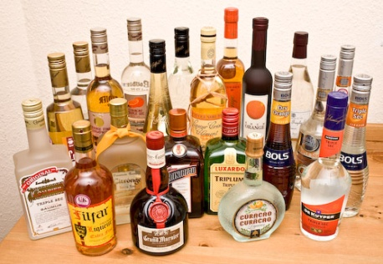
Call brands
A ‘call’ brand is the brand specified by or called out by the customer.
Instead of just asking for a ‘Scotch’, the customer would ask for a specific brand – perhaps a Johnnie Walker.
Most bars will stock a range of call brands, but no bar can stock them all.
You need to become familiar with the ones you stock so you can accept an order straightaway, or inform the customer you do not stock their preferred brand.
Always be alert to the possibility to up-sell the customer to a more expensive brand.
Where you do not have the call brand the customer asks for you should:
- Apologise for not having the brand asked for
- Offer an alternative.

2.3 Provide clear and helpful recommendations or information to customers on selection of drinks if required
Introduction
The majority of customers know what they want to drink and simply place an order with you, but there can be times when customers need some help deciding on what to drink.
This Section highlights that advising customers is a perfect opportunity to provide excellent customer service.

When might customers need help deciding what to drink?
Advice may need to be given when:
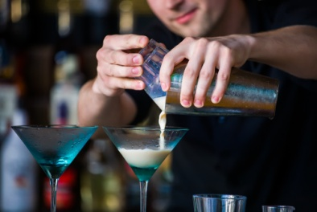
- Customers are unsure about what they would like – sometimes regular customers come in and they are just bored with their normal drink, and want something a bit different
- Customers who have never been in the bar before are uncertain about what you have available – they will appreciate help about liquors stocked, brands available and drinks which can be served
- The drink or brand customers have ordered is unavailable – apologise then recommend an suitable alternative
- It is a special occasion for the customer or group – perhaps they have just won a promotion, had a baby, or are celebrating a birthday: suggest something really different to their traditional drink – Champagne or sparkling wine is a usual choice for many
- You have a new product in stock – let the customers know: tell them what it is like, what it goes with, how much it costs, how strong it is, and so on.
Perhaps the boss will let you give away a few free samples – some companies will provide you with a couple of bottles to encourage you to give some free taste tests
- The customer is feeling ‘off colour’ or a bit low – you may want to suggest some refreshing style of drink, or a non-alcoholic alternative to their usual
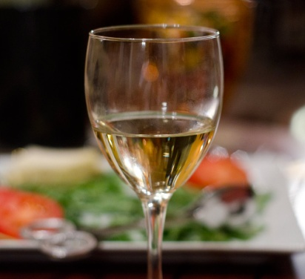
- They are dining – while a detailed knowledge of wine falls outside this unit, a very basic rule of thumb is:
- White meat – white wine
- Red meat – red wine
Nonetheless, many, many people drink a nice white (say, a Chardonnay) with a steak and there are many who are dedicated red wine drinkers and will drink a ‘good red’ with whatever they eat be it chicken, fish or anything else
- They do not want to drink alcohol, or they need to limit their alcohol intake – you have a duty to assist patrons who do not want alcohol, or want only a little.
Be prepared to offer fruit juices, waters, mocktails (non-alcoholic cocktails), alcohol-free wine and aerated waters. In addition, you must also become familiar with the alcohol strength of the liquor you serve, so you can help people to roughly determine their BAC.
What advice should I give?
When advising customers, it is useful if you can give them information about:
- Price – this is the price for:
- Individual drinks
- Different size bottles/cans
- Special promotions – informing them of:
- Discounts applying at the time – such as ‘Happy Hour’
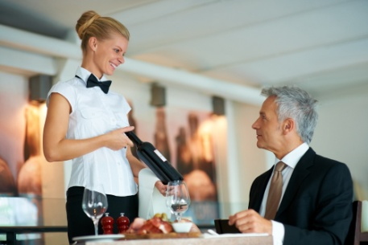
- Low prices for new drinks or brands being promoted at the time
- Details of the product – which may include details about:
- Flavour
- Ingredients it is made from
- Colour
- Aroma of the product.
Be prepared to let customers handle and have a look at the product
- Whether it is imported or domestic – including identification of the country of origin
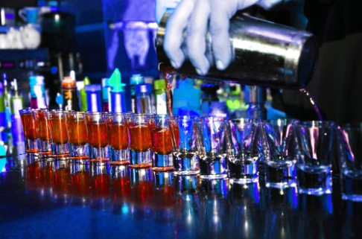
- How it may be served or consumed – give the customers some options about how they can experience the beverage:
- Can it be served over crushed ice?
- Can it be mixed with a fruit juice or aerated water?
- Can it be made into a cocktail?
- The alcoholic strength – never guess at this (for RSA reasons): read it from the label
- Any special points about the product – for example:
- Mention any awards it may have won
- Tell customers about special things like the worm in certain tequilas
- Inform guests about any special advertising campaigns running for it
- Tell them of any competitions people are eligible to enter if they buy it
- Explain the value-for-money it represents.

Work Projects
It is a requirement of this Unit you complete Work Projects as advised by your Trainer. You must submit documentation, suitable evidence or other relevant proof of completion of the project to your Trainer by the agreed date.
2.1 Provide a demonstration in (or submit video evidence of) a real-life/actual or simulated situation which provides proof you can:
- Take drink orders from customers at a bar
- Check product and/or brand preferences with customers in a courteous manner
- Provide recommendations and/or information to customers to assist with drink selection.

Summary

Take drink orders
When taking drink orders:
Greet the customer
Be polite
Be friendly
Be helpful
Provide advice, suggestions and recommendations
Repeat the order back to the customer
Clarify ambiguous orders
Note or memorise the order
Check for customer preferences.

Element 3:
Prepare and serve drinks

3.1 Greet customers in a polite, friendly and helpful manner

Introduction
Customer service is vital in the industry.
The level of the customer service you provide can be the factor which differentiates for the customer the venue where you work and your competitors.
This Section presents basic requirements for excellent levels of customer service in all bar situations.

Greeting the customer

Basic elements of a greeting
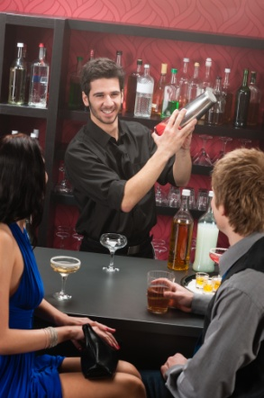
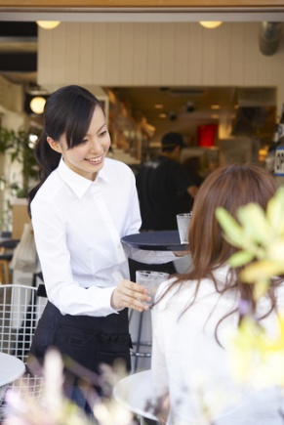
When taking a drink order, always greet all customers in a manner that is:
- Polite – this includes:
- Using customer name of known
- Saying ‘Please’ and ‘Thank you’
- Friendly – this includes:
- Smiling
- Showing interest in the individual
- Helpful – this includes:
- Making suggestions or recommendations
- Answering questions.
This applies whether you are taking orders at the table, or if the customer has come to the bar to order.
Customers must always be made to feel welcome and should never give the impression they are an inconvenience.
You may be really busy but serving customers remains your Number One priority – everything else takes second place even though those demands may be quite pressing.

Acknowledging and apologising
If a customer cannot be served immediately, they should at least be acknowledged verbally and with a smile – “Sorry, I’ll be with you in a moment”.

Never ignore customers who are waiting to be served.
Even a non-verbal acknowledgement (a nod of the head, eye contact, a hand signal) is appropriate in some circumstances.
Always try to serve customers in the order they were waiting – people become upset if served after a person who arrived at the bar after they did. If things are so busy you do not know who was next, the two options are:
- Ask customers who was next
- Work in a set pattern (left to right, or right to left) and serve the next person in-line in the direction you are working regardless of when they arrived – most customers will quickly understand what you are doing and accept it.
Check to see if your employer has other options or preferences and comply with what they wish.

3.2 Prepare drinks in accordance with legal and enterprise standards using the correct equipment, ingredients and measures

Introduction
The preparation and service of all drinks must conform to legal requirements and house practices.
A central aim is to achieve consistency of service and product.

Legal requirements
You must always ensure service of liquor aligns with the requirements of your country’s liquor licensing laws.
The specific requirements vary between countries so you need to investigate exactly what applies, and what is allowed and prohibited:
- In your country
- In the various bars or service areas in your workplace there can be different legal requirements in different parts of the same business.

Common liquor-related requirements
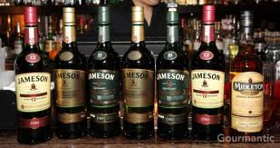
Many countries have regulations relating to:
- The age of people who can be served with liquor
- The age of people who can be in licensed venues – even though they are not consuming alcohol
- Hours that liquor is allowed to be served
- Whether liquor can be served for drinking on or off the premises
- The areas from which liquor can be served and sold
- Who may be served with alcohol – prohibitions may apply to certain classes of people
- Behaviour of people on licensed premises.
There may also be a requirement anyone serving alcohol must hold an RSA certificate.

Enterprise standards – drinks
Following are some enterprise standards used when preparing and serving drinks – they indicate glassware, ingredients and measures.
Remember each establishment may have its own guidelines and these should take preference over the following to achieve the required consistency and/or profit targets.
Soft drink
Glassware: Highball
Method: 1/3 full of ice
Add soft drink
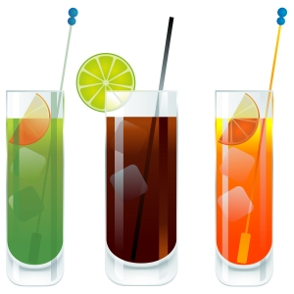
Garnish/Additional: Straw
Add a slice of lemon to mineral water, soda water, water, lemonade, tonic and squash
Juice
Glassware: Highball
Method: 1/3 full of ice
Add juice
Garnish/Additional: Straw
Slice of lemon or orange according to juice type
Spirit – ‘on the rocks’ or ‘on ice’
Glassware: Old Fashioned
Method: 1/3 full of ice
Measure of spirit (30 ml)
Garnish/Additional: None

Spirit with mixer
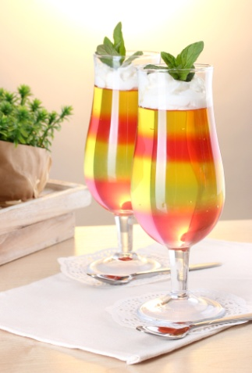
Glassware: Old Fashioned (for short glass)
Highball (for long glass)
Method: 1/3 full of ice
Measure of spirit
Add mixer
Garnish/Additional: Straw – optional
Lemon garnish – in clear spirits: vodka, gin, tequila
Orange garnish in all orange-based drinks
Liqueur – neat
Glassware: Liqueur glass
Method: Measure of liqueur
Garnish/Additional: Not normally
Liqueur – with mixer
Glassware: Old Fashioned or Highball
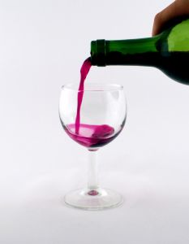
Method: Measure of liqueur
Add mixer
Garnish/Additional: Straw
Lemon or orange garnish if required
Wine – red or white
Glassware: Wine glass
Method: Dispense out of cask or bottle
Garnish/Additional: None
Bottled beer
Glassware: Pilsener or Pot/Handle
Method: Open bottle
May need to pour beer before serving (tilt the glass to avoid creating a large head), or house rule may be to allow customer to pout their own
Garnish/Additional Normally none (lemon or lime wedge with Corona)

Draught beer
Being able to ‘pull a beer’ is an essential skill for all bar staff.
It is important when pulling beer to avoid spillage or wastage: beer costs money, you’re your boss will not be impressed if you waste it.
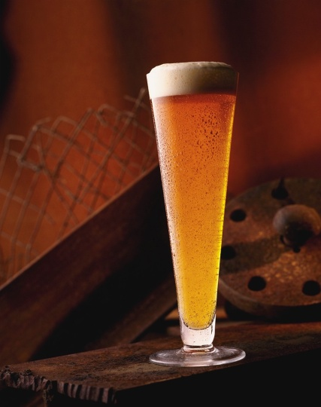
A good beer:
- Has about 2.5 cm of head
- Should be cold enough to put a frost on the outside of the glass
- Should be slightly effervescent.
Glassware to choose from can include:
- Pot
- Handle
- Pilsener
- Glass.

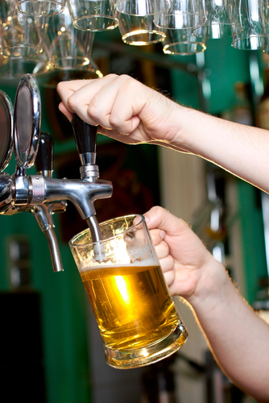
Pouring draught beer
The following are the steps involved in pouring a draught beer.
1. Keep the glass away from the tap, hold the glass on an angle to break the fall of the beer.
Never hold the glass straight up and down, or the beer will have too much head: do not knock the glass against the tap or it may crack or chip the glass.
2. Turn the beer tap on quickly and ensure the glass is angled so beer hits the side of the glass about halfway down the main trunk.
Never turn the tap on slowly, or the beer will ‘squirt’ out from the beer tap and result in loads of froth and wastage.
3. As the glass starts to fill and the beer reaches three quarters of the way up the side of the glass, lower the glass away from the tap and straighten it.
Keep pouring beer until the glass is full and has the appropriate amount of head: you may have to ‘drop’ the glass to get the ‘head’ right.

Things to remember when pulling draught beer
Do not over-pour beer
If you fill the glass too much this will:
- Give the beer no head
- Waste beer
- Produce a very unattractive looking product.
Check the quality of the product
If beer is pouring heady, cloudy, slow or warm, alert the appropriate person (cellar person, supervisor) immediately.
Always use clean glasses
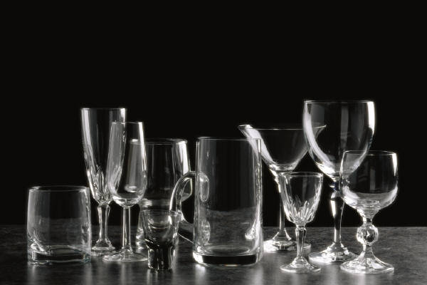
It is standard practice to use as fresh glass for every beer – you should not re-fill a previously used glass.
Grease from people’s lips (who are eating a meal) and lipstick can flatten beer.
Ensure glasses have lipstick removed – hand washing can be necessary to achieve this.
Make sure glasses are not cracked or chipped before using them: a visual inspection is required.
Never touch/knock the glass on the tap
This is a common way in which expensive glasses can be chipped, cracked or broken.
Hold the glass near the base
Glasses must not be held around the rim – it looks bad to the customer and raises cross-contamination and hygiene issues.
Hold the glass around its bottom half/part.
Never put your fingers in the glass.
Do not let beer flow over the side of the glass
This is not only wasteful but it really annoys customers when they pick up their beer and it may drip down on their clothing.

Non-alcoholic beverages
As with alcoholic drinks, customers may have individual preferences for their nominated non-alcoholic drinks.
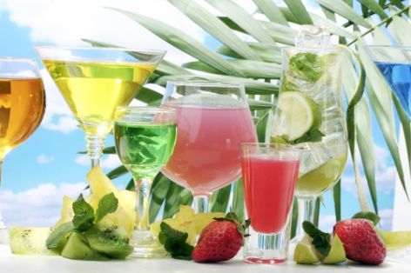
Bar staff must ensure they treat the service of non-alcoholic drinks with the same expertise and professionalism as they do the sale and service of alcoholic drinks – the consumption of non-alcoholic drinks is rising (given drink-driving legislation, health concerns and social issues related to alcohol consumption) plus establishments often obtain a better financial return on non-alcoholic drinks than they do on alcoholic ones.
Non-alcoholic drinks can be hot or cold.

The usuals
In many establishments, the only non-alcoholic drinks are the ‘traditional’ sort – proprietary brand lines of fruit juices, aerated waters and waters.
Examples are:
- Juices – tomato, orange, apple, pineapple, mango
- Waters – a wide range includes still, sparkling, mineral, and even tap water
- Aerated (also known as ‘carbonated’) waters – these are the soft drinks such as cola, lemon squash, dry ginger, lemonade, soda water, tonic water: these may be dispensed from a post-mix machine or served from bottles or cans.

Mocktails
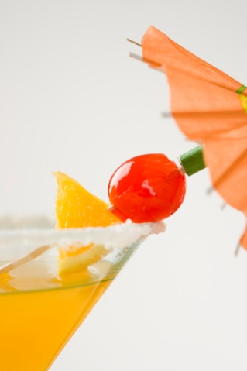
MOCKTAILS is a trade mark.
Excellent recipes for mocktails can be found in Graeme Goldsworthy’s book “101 MOCKTAILS”.
Mocktails are non-alcoholic cocktails looking like an alcoholic drink, served in the same style of glass as an alcoholic cocktail but contain zero liquor.
Your establishment may have a special Mocktail List, or you may work in a venue simply serving traditional non-alcoholic drinks such as fruit juices and soft drink/aerated waters.
You can invent your own mocktail – ensure it is tasty, looks inviting and of course, contains no alcohol.
See http://cocktails.about.com/od/mocktailmocktail/Mocktail_Recipes.htm.

Frappes
Frappes are cold drinks made by blending ice together with other ingredients such as coffee, fruit, milk, flavourings, yoghurt and/or fruit juice.
They can include shaved ice with ingredients poured over it.
They are very popular where customers are health conscious and/or where there is a strong demand for non-alcoholic beverages to be served.

Coffee
When you work behind a bar you may be required to operate a variety of coffee equipment/machines:
- Dripolator – ‘Cona’-style filter coffee: frequently used in self-serve situations
- Plunger – available in different sizes and may be placed on the customer’s table for self-serve
- Espresso machine – very popular for service of cappuccinos etc
- Percolator - may be used at large functions: can hold over 50 cups.
All coffee machines should be wiped down externally during a shift and dismantled and cleaned fully at the end of each shift.
There are many different types and models of coffee machines – in-house/on-the-job training will show you how to use the one at your workplace.

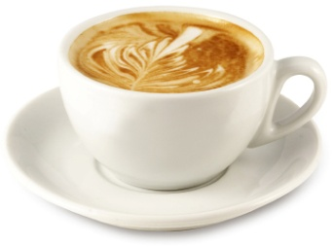
Coffee recipes
Cappuccino – normal cup
- 1/3 espresso coffee
- Fill cup with 80% hot milk
- Top with milk froth
- Sprinkle with chocolate powder.
Flat White – normal cup
- Use the same recipe as for a cappuccino
- No froth
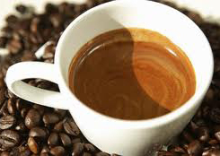
- No chocolate powder.
Short Black – demitasse cup
- Fill small (demitasse) cup with black coffee.
Café Latte – coffee glass
- Fill glass with 1/3 coffee
- Top with hot milk.
Ristretto – demitasse cup
- Shorter than a short black and double the strength of a short black.
Vienna Coffee – tall glass (handled)
- Same as a long black
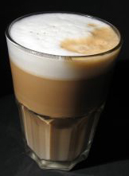
- Top with whipped cream
- Sprinkle with chocolate powder.
Iced Coffee – tall glass with a spoon
- 1/3 cold espresso
- Add ice cream
- Top with cold milk
- Top with whipped cream
- Sprinkle with chocolate powder.
More recipes and information on espressos?
To obtain more information about coffee and espresso, go to:
- http://coffeetea.about.com/od/espressorecipes/Espresso_Recipes.htm
- http://www.espressoplanet.com/espresso_recipe.htm.

Tea
While the service of coffee has started to become popular in some bars, the service of tea has not reached the same heights.
There are many types of tea available with some featuring effective eye-catching displays for presentation on the bar/behind the bar to promote the sale of teas:
- English breakfast
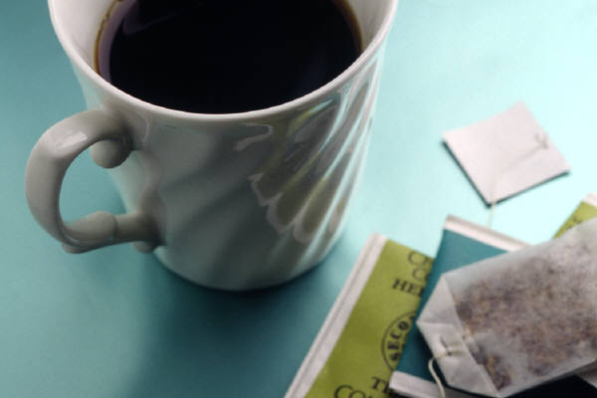
- Irish breakfast
- Ceylon breakfast
- Darjeeling
- Earl Grey
- Jasmine
- Chamomile
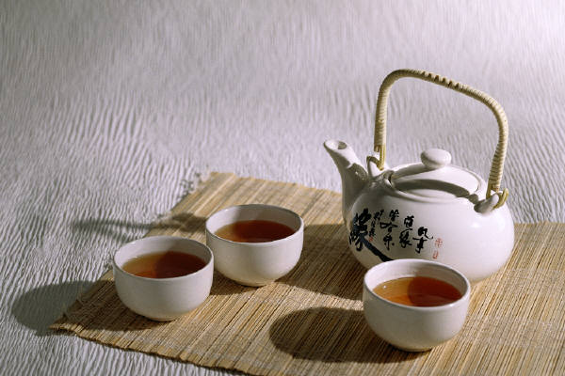
- Peppermint.
Depending on the establishment, service of tea can be:
- In a teapot
- In a cup using a tea bag.
Tea should be served with milk (white tea) or slices of lemon (black tea) on the side.
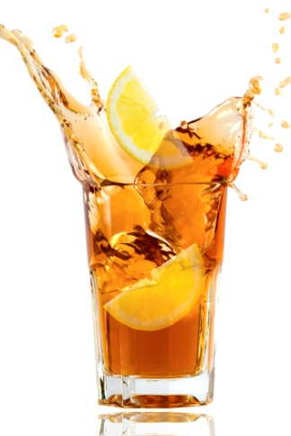
Never forget to provide the customer with a plate for the used tea bag, where appropriate.
Iced tea – highball glass
- Make quarter of a cup of strong tea
- Place tea in shaker full of ice
- Shake and strain into a glass full of fresh ice
- Garnish with a slice of lemon.
Websites
If you are interested in more tea information and recipes, visit:
- http://coffeetea.about.com/od/tearecipes/Tea_Recipes.htm
- http://www.tbythesea.com/tearecipes.html.

3.3 Serve drinks promptly and courteously

Introduction
Once the drink order has been taken, it is important to prepare and serve all beverages in a prompt and courteous manner according to known or stated customer preferences.
This Section explains the requirements for prompt and corteous bar service of beverages.

Providing prompt and courteous service
The basics elements of providing prompt and courteous service for drinks are:

- Thank the customer for placing the order – always thank the customer for every order they place
- Fill the order as quickly as possible – this may involve:
- Making the drink straight-away
- Preparing the drink ‘in turn’
- Interpret the order properly – make sure you:
- Comply with special instructions made by the customer, such as ‘extra ice’, ‘long glass’ or ‘two slices of lemon’
- Use the ingredients requested by the customer – where possible
- Apply house ‘standard recipes’ for the preparation of mixed drinks and cocktails – where customer wants to depart from these standard practices there may be a need to charge extra for different ingredients or extra ingredients
- Never sacrifice accuracy and cleanliness of drink preparation for speed – customers will always prefer to have a properly made/served drink rather than one which gives them less than what they paid for, and/or is served in a sloppy fashion
- Use the right glass for the right drink – the basis for this is:
- House recipes
- Tradition
Never over-fill glasses.
- Follow required mixing/preparation methods – for example:
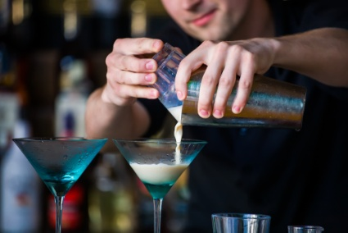
- For mixed drinks the accepted sequence is:
- Get the glass – check it is clean and not cracked
- Add the ice to the glass
- Add the spirit
- Add the aerated water/mixer
- Add the garnish and/or decoration
- Serve – may be served with a coaster
- Follow ‘house protocols’ – where they differ from the above
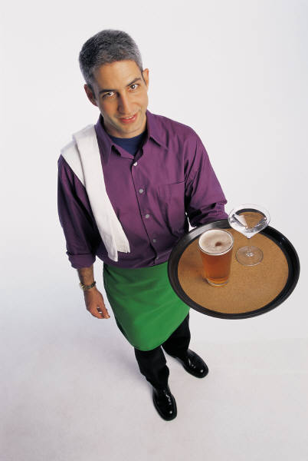
- Serve the drink as soon as possible – this may require:
- Physically handing the drink to the customer
- Notifying wait staff the drink is ready to be served
- Prompt service of the drink once it has been made is important to:
- Optimise enjoyment of the drink – most drinks should be served cold and they will quickly warm-up and become less pleasing if allowed to stand on the bar for even short periods of time
- Avoid customer waiting time – patrons do not like being kept waiting for the drinks
- Name the drink as you present it to them – ‘Your brandy and dry, Sir, with extra ice’
- Thank the customer – when you give them their drink
- Offer a pleasant sentiment – ‘Enjoy!’

3.4 Handle and use industry standard glassware and use garnishes and accompaniments appropriately

Introduction
Industry and or venue standards must be applied when handling and using glassware ad garnishes/accompaniments.

Glassware
Following are some industry standards for the use of glasses.
Remember each establishment may have its own guidelines and these must be followed where they differ to what is presented below:
Glass | Drink | Glass | Drink
Highball  Pilsener | Soft drink  Juice | Old Fashioned | Neat spirits  Spirits ‘on ice’  Short mixed drink
Liqueur glass | Liqueurs | Old Fashioned (Short)  Highball (Long) | Liqueur with mixer
Stemmed wine glass | Still table wine  Larger glasses used for red wine; smaller glasses for white wine | Pot  Pilsener  Handle  Mug | Beer
Champagne flute | Champange and other sparkling wines | Port glass | Fortified wine

Handling glassware
The following are standard industry requirements applying to the handling of glasses:
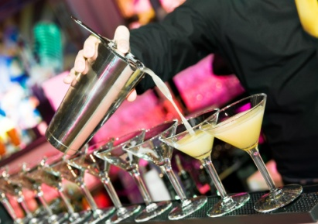
- Check all glasses before using them or offering them – no cracks, no chips: they must be clean
- Use the same type of glass for the same type of drink – to give consistency
- Handle glasses by stem or base – not by the rim
- Be careful – glasses are fragile and easily broken.

Points to remember when making garnishes
- Always use a clean surface when cutting garnishes
- Always have plenty of fresh garnishes prepared before service
- Always store garnishes under refrigeration
- At the end of trading, all garnish containers should be sealed with a lid or a good quality clear wrap
- Never re-use garnishes that come back from the table/customer – they may be contaminated
- You are not permitted to eat the garnishes – or the raw materials from which they are made.

Garnishes
Most recipes stipulate a specific garnish for the drink – in some cases changing just the garnish can change the name of the cocktail.
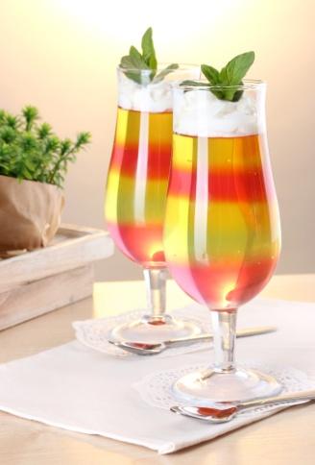
For example, a dry martini garnished with a cocktail onion instead of an olive or twist of lemon is called a ‘Boston’.
Garnishes are food-based – as opposed to other decorations which are made from paper, wood and/or plastic.
It is important to keep garnishes simple.
Using too much in the way of garnishes can spoil the presentation of the drink, and detract from the other appealing features of the finished product.
Also, remember garnishes can be costly so they should be used, handled and stored with this in mind.
Common items used for garnishes for cocktails are:
- Citrus slices – half and full
- Maraschino cherries – speared on to either one or two toothpicks
- Olives – speared on a toothpick, traditional with a dry martini
- Pineapple, and citrus wedges – pineapple done like this is also called ‘pineapple spears’. Pineapples may also be hollowed out and used as the ‘glass’/service item for some cocktails
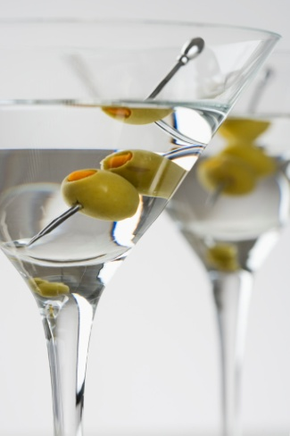
- Citrus twists – the twisted zest of citrus fruits
- Celery rib – used traditionally for a Bloody Mary
- Sprigs of fresh herbs – rosemary, thyme and mint are common
- Kiwi fruit – half or full slices
- Chocolate powder – sprinkled on top of the finished drink
- Whole strawberries – or sliced strawberries (sometimes chocolate-dipped)
- Nutmeg – sprinkled as a powder, or used as a stick
- A range of other products can be added to different, more modern cocktails – coffee beans, liquorice sticks, jelly beans, jelly babies.

Garnish options
There are a wide variety of garnishes available for adding to drinks/mixed drinks and cocktails.
Some are traditional, and many are the result of personal preference.
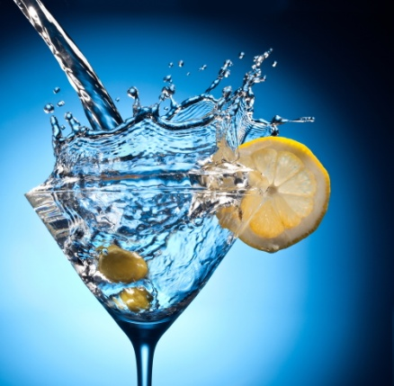
As a basic list of standard garnishes, you should be able to produce the following:
- Slice of orange or lemon – full slice, half-slice and quarter-slice
- Wedges and knots/twists – of lime, lemon or orange
- Lemon or orange wheel
- Olive on a toothpick – and Maraschino cherry on a toothpick
- Slice and cherry – a slice of, for example, orange with a cherry attached by a toothpick. The slice is slightly bent to give the garnish a ‘sail’ effect.

Edible flowers
Flowers are sometimes used as garnishes for cocktails – both as heads floating in drinks, or frozen in an ice block which is placed into the drink – but some flowers are poisonous so some venues avoid them.
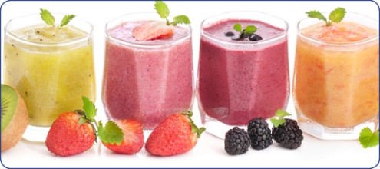
Edible flowers include:
- Nasturtiums
- Marigold
- Borage
- Ranunculus
- Primrose
- Rose
- Crystallised poppies.

Drink decorations
These are commercially prepared decorations that cost money.
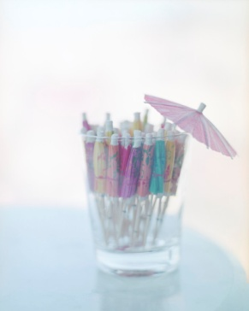
They are most commonly used with cocktails but may be used on other long drinks as well.
They are not food-based (meaning they are inedible) and include:
- Paper parasols – stuck into a wedge of fruit
- Plastic animals – hung off the side of the glass: monkey, giraffe, dolphin, elephant
- Mermaids – also hung from side of glass
- Pickaxes – can be used to hang cherries onto side of glass
- Doilies – sometimes placed under drinks
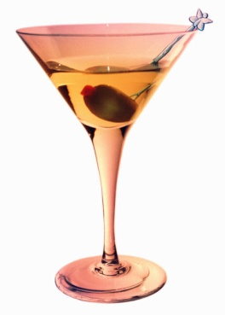
- Swizzle sticks – placed into a cocktail for the customer to stir the drink if they choose
- Sparklers – to add a fiery dimension to cocktails and popular for use at celebrations
- Straws – placed into the cocktail and should be the right size: flexible long straws are commonly used in tall cocktails, and other alternatives include normal full-length straws, and half-straws.
When using or adding decorations to cocktails:
- Make sure you use only the amount of decorations as specified in house recipes – no more, no less
- Never over-decorate – the finished product should look like a drink or cocktail and not a fruit salad.

3.5 Minimise spillage and wastage and attend to accidents during service promptly and safely

Introduction
Wastage and spillage costs the venue money and usually slows down or otherwise adversely impacts on service.
You must do everything possible to minimise it or eliminate it.

How and why does wastage and spillage occur?
Wastage and spillage will occur more if you rush: this is the main cause of wastage and spillage.
The following undesirable consequences may occur – you may knock bottles and glasses over, you may overfill glasses, you may knock bottles against each other and break them, and you may knock glasses against taps and crack them.
If you break an unopened bottle, check with your supervisor to see if they want the top of the bottle (the part with the intact seal, or cap) kept. A decreasing number of suppliers will replace broken bottles free-of-charge where the seal is still intact.
Lack of training can also cause waste, especially with beer pulling, mixing drinks and cocktails, carrying trays, pouring bottled product (especially wine and beer).
Failure to store opened products properly after service has finished can also cause waste – tops must be put on open bottles to preserve the contents (if this is house policy), and they must be refrigerated where appropriate.
Note some establishments have a policy of throwing out any open bottles and cans at the end of trading, as they believe the customer would receive an inferior quality product the following day, and the few cents saved is not worth the bad public relations caused.

House policies
House policies regarding waste and spillage vary.
Your workplace may require you to record waste in a book (such as an Ullages Book) – this may include recording waste beer from beer drip trays, a bottle dropped and smashed, and drinks knocked over.

This book may also be used to record ‘promotional’ drinks – that is, drinks given away by the establishment with the approval of management for promotional purposes or to replace drinks accidentally knocked over, or drinks given away in order to compensate for poor/bad service. These are known as ‘Comp’ drinks.
Your venue will also have a policy on replacing drinks which customers knock over. Many establishments will replace soft drinks, house wines and beers free of charge, but charge for replacement spirits and premium wines.
Some places will replace everything free-of-charge, some will charge for everything.
Things become tricky when a customer knocks over a drink you believe was nearly empty, and then demands you replace it – free of charge: check with your supervisor to see what the house does in these circumstances.
Often the decision made will depend on the customer in question – questions address issues such as:.
- Are they a regular?
- Do they spend significant money with you?
- Are they part of a larger group spending well and not causing any trouble?
- Is it house policy?
Venues usually ban staff from drinking while on duty.


Dealing with the issue
When dealing with broken glass in a bar situation you musty follow housie policy.
House policy about the removal of broken glass is usually not written down anywhere but commonly exists as standard procedure in the head of the owner, manager or supervisor – so ask them what you should do.
In some limited cases, there may be a ‘work instruction’ (or similar) outlining what needs to be done and how broken and chipped glasses should be handled.

Standard practice
Commonly, the broken glass is swept onto a shovel or dustpan and simply thrown in the bin – this bin may be the bin behind the bar, or a larger bin or dumper outside.
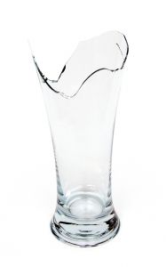
Where the item is just chipped or cracked the usual disposal method is to just throw it in the bin, making an effort not to break or smash it.
In these days of increased Occupational Safety awareness, a responsible approach for disposal of broken glass would be to:
- Sweep the broken glass into a cardboard box – using dustpan and brush
- Seal the box – there are always boxes lying around somewhere behind the bar
- Dispose of it into bin.
Alternatively, the broken glass could be wrapped in thick layers of newspapers, taped closed and then disposed of.
Some premises have a designated ‘broken glass’ container behind the bar for dealing with such eventualities.
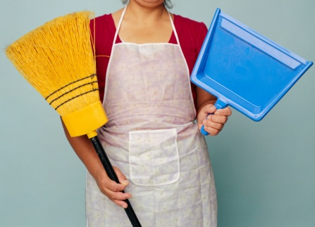
Employers must provide the necessary equipment for disposing of broken glass and this should include suitable protective equipment/clothing such as an appropriate pair of gloves, plus (perhaps) a small shovel/dustpan and brush.
It is not acceptable to use your bare hands to pick up/clear up broken glass.
Environmental considerations may require you to dispose of glass in a special container/bin for the purposes of recycling.

3.6 Seek assistance from appropriate people for situations which pose a threat to safety or security of colleagues, customers or property

Introduction
All venues are under an obligation to care for the safety and welfare of people when they are on the premises.
This Section identifies action you may take to address identified threats.

Duty of Care
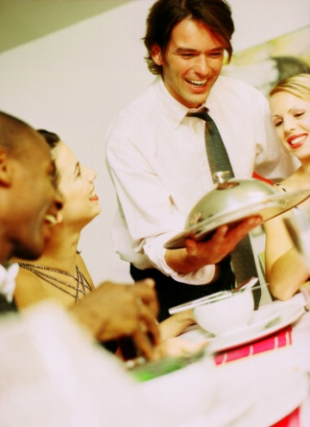
All venues are under a ‘Duty of Care’ to protect everyone who comes into the premises.
This obligation applies to anyone who is on the premises – such as:
- Customers, guests and patrons of any type
- Staff
- Members of the public
- Delivery drivers
- Service men and technicians who are installing or repairing equipment and systems.
Duty of Care obligations means the premises must take necessary action to protect people from ‘foreseeable harm’.
If the business fails to do this they can be held liable for ‘negligence’ and sued by those who may have been injured (or lost property) as a result of that negligence.
This means the venue is under an obligation to take action when it identifies a situation which poses a threat.

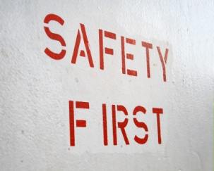
Situations which may pose a threat

Threat defined
In the context of a bar, a ‘threat’ may be seen as:
- Anything which exposes the venue to legal action – that is:
- Being charged by police or the authorities
- Being sued by customers
- Anything which places the safety of individuals in danger and or jeopardises the security of physical property – including stock, cash and personal belongings.

Anything which exposes the venue to legal action
Anyone whose presence on the premises renders the business liable to an offence under the liquor licensing legislation is cause for concern – this may be someone who is:
- Under legal drinking age
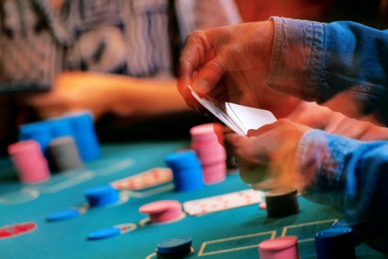
- Intoxicated or drunk
- Violent
- Gambling in a way prohibited by law for the venue
- Disorderly – annoying others; making too much noise; not behaving in an acceptable way
- Trying to obtain liquor for someone who has been refused service
- The subject of an exclusion order
- Quarrelsome or argumentative
- Trying to obtain liquor outside licensed hours
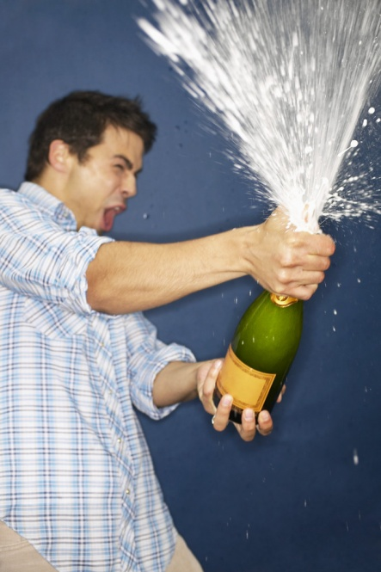
- Unable to be served with alcohol given the type of licence in operation
- Identified by legislation as not being allowed on licensed premises – this will vary between countries and may include known prostitutes, known criminals and or people who associate with known prostitutes or criminals.

Anything which impacts safety or security
This may include:
- Customers who are drunk, violent and quarrelsome
- Patrons who are threatening or intimidating others
- People who are fighting
- Extreme weather events
- Equipment breakdowns which pose a hazards
- Gate crashers
- Power failures
- Emergency situations – such as fire, gas leaks, any situation creating a need for evacuation.

Responding to threat situations
The keys to responding to threat situations are:
- Follow workplace policies and procedures – many venues have Emergency Management Plans in place to deal with these situations and conduct drills to assist you become familiar with what you need to do when faced with such a situation. Make sure you determine what is required and participate in the training/drills.
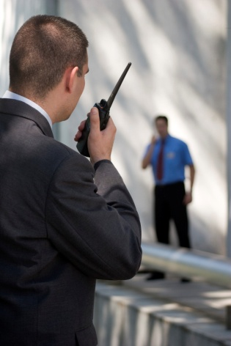
- Notify others promptly – as soon as you become aware of a situation you must report it. It is a fact of life situations never resolve themselves so you have to notify the appropriate person (see below) in order they may take the most appropriate action to resolve/address the identified problem.
- Provide details of the situation – such as:
- Location of the problem
- Number of people involved
- Reason for your concern
- Details of anything already said, or action already taken in relation to the issue
- Take action where authorised to do so and when safe to do so – this may include:
- Removing customers to a safe area
- Securing property – by locking doors and cash drawers
- Initiating a first response - such as fire fighting
- Calling external authorities for assistance.
When taking action always put the safety of people above the security of property: people must always take priority over money or other physical resources/assets.


‘Appropriate person’
The appropriate person may be:
- Supervisor
- Bar manager
- Duty manager
- Security officer
- Front desk service agent
- Owner.

3.7 Seek feedback from customers in order to identify and implement improvements to beverage quality and take appropriate corrective action, if required

Introduction
It must be part of standard operating procedure to always check the quality of all beverages you serve.
No sub-standard product/beverage must ever be allowed to leave the bar for service to a customer, regardless of who the customer is, or how much/little they are paying for the drink.
This Section identifies how to check beverage quality and presents possible corrective action.

Seeking feedback
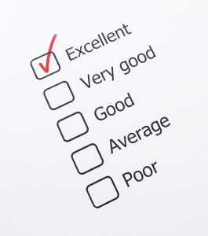
You should actively solicit feedback from customers about the service they are receiving and the quality of the drinks they are being served.
The best ways to do this are:
- Ask for feedback – verbally or by asking customers to complete a ‘Customer Comment Feedback’ form
- Listen to what customers are saying to each other – are they complaining to each other, or do they seem happy with what is happening? Follow up with a question where you think there may be a problem – the sooner you know, the better
- Observe customer body language – do they appear pleased or displeased: ask a question if you suspect a problem
- Note the drinks which are being left unfinished – a trend in a certain type of drink may indicate a problem
- Encourage feedback – tell customers to let you know if they have compliment, complaint or opinion they want to share.

Checking beverage quality
Checking beverage quality must be an ongoing effort.
Every time you prepare, or serve, a drink it must become second-nature for you to check its quality.
The rule is simple – if you would not drink it, if you would not like it served to you: then do not serve it to anyone else.
There are no exceptions to this rule.

Things to check
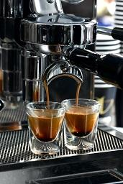
While there are health and hygiene considerations – clean glass, no contaminants, correct personal hygiene practices – there are also other product-specific concerns you should be monitoring:
- Temperature:
- Cold drinks should be cold
- Hot drinks should be hot.
Every bar should have its own thermometer to be used to objectively test/take the temperature of beverages if there is a concern they are not (for example) cold enough.
You should use the feel of your hands on products/glasses, as well as the readouts on refrigeration units, to judge temperature.
- Taste – making sure:
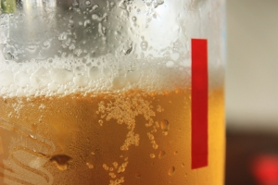
- There are no ‘off’ tastes
- The beer is not ‘green’ (sour)
- Wine has not oxidised
- Post-mix brixing is correct
- Smell – there must be no ‘off’ smells
- Clarity – check to ensure:
- The product is not cloudy
- There is nothing floating in the glass, bottle or jug.

Responding to a problem
The basics for taking corrective action are:
- Take action – never ignore the situation and simply hope ‘no-one will notice’ or ‘the problem will solve itself’
- Remove the product from sale – do not sell/serve any more of it. Where you believe the product poses a risk to public health, you must also initiate immediate action to retrieve from customers any of the affected product – this means you may have to walk around the bar/tables looking for the product and removing it from patrons: you will have to apologise for this, explain the situation and offer an appropriate replacement drink
- Keep the offending bottle, drink, item safely to one side – so it can be shown to your supervisor or examined later in more detail
- Advise other service staff immediately about the problem and the beverages involved – so they do not serve/use the product
- Inform management about the problem.

Reporting beverage quality issues
Where you become aware of a beverage quality issue within the bar you must immediately notify a supervisor and get them to come and make a decision about what has to happen to address the problem.

What action must you take?
It is critical as soon as you notice (or are informed by a patron) of any beverage quality issue you notify your supervisor immediately: this is the first step you must take.
It is strange but as soon as one person says they think the beer (or whatever) tastes ‘bad’ or is ‘warm’ – everyone else starts agreeing with them whether they are right or not.
You have to take immediate action to fix the problem before things get to the stage where all customers start complaining.

What if the customer has complained/made you aware of the problem?
If it is a customer who has alerted you to a problem, then you must be seen to be taking action to fix the problem: the customer must believe you have taken their complaint/notification seriously and are doing something to rectify the situation.
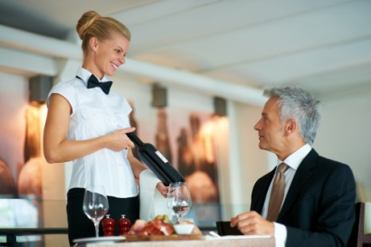
The most effective response is:
- Thank them for their complaint
- Apologise
- Offer a suitable alternative
- Advise them you are immediately notifying management so they can take the appropriate action.
What if there is no manager or supervisor to refer things to?
If someone complains about the quality of the product and you are unable to obtain management input on the problem, you will be expected to cope with the situation as best you can.
Doing nothing is not an option; ignoring the situation and hoping it just goes away is not an option.
You may be given a prescribed scope of authority for dealing with these events and this may provide some guidance on what you can/should do.
Where no guidance on what to do exists, the following may assist your thinking:
- Thank them for their complaint
- Apologise
- Make an objective decision about whether or not their complaint has substance – you must determine from a fair and reasonable standpoint whether their complaint about warm beer, an off-tasting wine etc is genuinely justified. This may mean you have to:
- Take the temperature of the product/beer – do not take the temperature of their beer, but pull through three glasses of beer through the tap and take the temperature of the fourth one in the glass
- Taste the product – to your palate, does it taste OK, or is there definitely a problem?
- Smell the product – does it have off-aromas or is the smell correct and acceptable?
- Look at the product – does it look normal as it usually does? Are there unacceptable things floating in it? If it is supposed to be clear, is it clear or cloudy? Is it the right or usual colour?
- If, after assessing the beverage yourself, you believe their complaint is valid, then you need to take some action to fix the problem – the customer has done you a favour by complaining
- If you genuinely believe the complaint is without basis, you may elect to (nonetheless) apologise to the customer, and still replace the drink in question, free of charge: sometimes it is easier to replace a perfectly good drink rather than argue about whether there is a problem or not
- Your house policy will provide further indication about what applies at your workplace.

3.8 Deal with unexpected situations in accordance with enterprise procedures

Introduction
It is difficult to predict all unexpected situations which can arise when operating a bar but you must develop the capacity to respond to all of them promptly and effectively.
This Section identifies generic response requirements, provides examples of unexpected situations with possible responses and introduces the concept of pre-determined decisions.

Generic response requirements
All unexpected situations must be attended to immediately and professionally.
It is important not to panic when an event occurs.

Generic responses should be:
- Identify and recognise the problem as soon as possible
- Analyse the situation:
- What is the problem/issue?
- What impact will it have on service/customers?
- Decide the best course of action to take – given the circumstances
- Take action – two keys are:
- Use common sense
- Follow internal EMP or pre-determined decisions
- Notify the appropriate person straightaway – supervisor/management or Security.

Examples of unexpected situations and possible responses
When working behind a bar you may have to deal with the following situations:
- Dealing with equipment breakdowns – response may be:
- Notify management or Maintenance
- Arrange replacement item
- Tag broken item as ‘Out of Order’
- Make sure others do not use it
- Remove item from service – if possible
- Advise customers of products which cannot be produced and served due to item breakdown
- Dealing with power failure – response may be:
- Notify management or Maintenance
- Implement EMP for ‘power failure’ – evacuate customers; activate emergency/stand-by generator; verify emergency lighting has activated
- Protect assets/cash
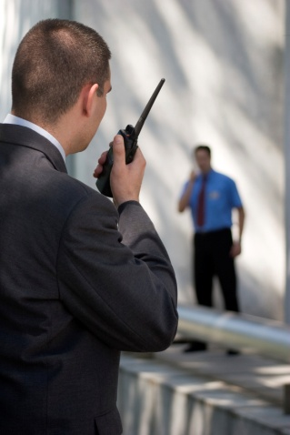
- Urge people to keep calm
- Use ice to chill bottles and cans
- Switch to manual operation of POS terminals
- Dealing with violent incidents – response may be:
- Notify management or Security
- Implement EMP for ‘violent incidents’
- Never place self in danger – do not intervene
- Move customers to safety
- Ask people to modify their behaviour
- Contact police/authorities – if scope of authority allows
- Dealing with medical emergencies – response may be:
- Notify management, Security or reception – or House Doctor, or designated staff member trained in First Aid
- Provide basic first aid
- Comfort and re-assure patient
- Contact ambulance authorities – if scope of authority allows
- Dealing with running out of stock – response may be:
- Predict the situation – try to avoid actual stock outages
- Notify management and request extra stock
- Requisition stock from Store
- Borrow stock from another department – completing an inter-departmental transfer sheets if required
- Dealing with employee absences – response may be:
- Notify manager or supervisor if staff are absent
- Close sections of the work area
- Reduce service and or items offered
- Work extra hours to cover absences – if authorised.

Using pre-determined (‘programmed decisions’) decisions
Most establishments will have a set of guidelines for you to follow where certain predictable situations or mishaps arise.
These pre-determined decisions will allow you take immediate on-the-spot action when a mishap occurs and saves you involving management in every single minor mishap/decision.
Examples of pre-determined decisions may be as follows.
Mishap | Pre-determined action/remedies staff may be authorised to take
Staff member knocks over customer’s drink at the bar | Apologise  Replace drink, free-of-charge
Staff spills tray of drinks over guests at table | Apologise  Immediately obtain help from other staff  Clean/dry affected areas – offer cloths for guests to dry their own clothes  Replenish and re-serve drinks  Contact supervisor who will make decision on any further action, or on reimbursement

Work Projects
It is a requirement of this Unit you complete Work Projects as advised by your Trainer. You must submit documentation, suitable evidence or other relevant proof of completion of the project to your Trainer by the agreed date.
3.1 Provide a demonstration in (or a video evidence of) a real-life/actual or simulated situation which provides proof you can:
- Greet patrons who order a drink
- Take their order
- Thank them for their order
- Prepare required drinks in accordance with legal requirements and standard industry and house practices
- Serve drinks promptly and courteously handling glassware correctly and hygienically and adding garnishes and or decorations as appropriate
- Minimise spillage and wastage during preparation and service
- Seek feedback from customers regarding drink/beverage quality.
3.2. Provide a written submission suitable for use by staff in a bar situation detailing:
- Situations which may pose a threat to staff and/or customers
- Who the threats identified above should be reported to
- Possible effective responses for dealing with the following ‘unexpected situations’ in a bar:
- A fight
- Bar runs out of beer
- A fire.

Summary

Prepare and serve drinks
When preparing and serving drinks:
Greet the customer
Be friendly
Acknowledge the presence of any customer who may have to wait to be served
Apologise if customer has to wait
Thank the customer for their order.
Follow all legal requirements regarding service of alcohol
Adhere to house protocols when preparing and serving drinks
Serve drinks promptly and courteously
Handle glassware carefully and hygienically
Add garnishes and decorations as appropriate
Take care to minimise spillages and wastage
Clean up breakages carefully and safely
Monitor patrons and seek assistance where customer behaviour requires attention
Follow house rules when responding to threats
Never place yourself in danger
Seek feedback from customers about drinks
Check quality of beverages on an on-going basis
Report problems with beverage quality as required
Take corrective action to rectify beverage quality if possible
Respond sensibly to unexpected problems.

Element 4:
Close down bar operations

4.1 Greet customers in a polite, friendly and helpful manner

Introduction
At the end of trade, various items of equipment will need to be turned off, or shut down.
This Section identifies what may need to be turned off – and on at the end of operations and the checks which may need to be made.

Background
The equipment in venues can be expected to vary, and even where venues share the same equipment, what they do with it at the end of trade can differ based on personal preference, prior history/experience and organisational policies.
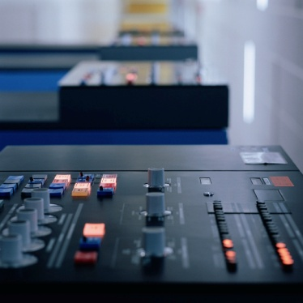
For example, some venues will leave a machine on that throws out some light – using it as an inexpensive way of providing internal ‘security’ lighting while the premises are closed.

What equipment is involved?
In general terms, if the equipment had to be turned on the start of the day, it will need to be switched off at the end of the day.
Equipment which may need to be turned off includes:
- Instantaneous beverage chillers
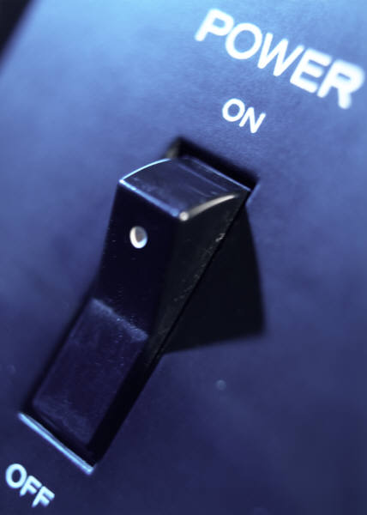
- Radio, tape, CD or other music source, PA systems, televisions
- Heating or air conditioning units
- Lighting
- Coin-operated entertainment units
- Vending machines
- Advertising signs
- Glass chillers – so they can defrost overnight and be ready to clean the next morning
- Coffee machines.
You should always be shown what to turn off – and how to turn it off – by a more experienced staff member, and then be supervised for the first few times you are required to turn equipment off.

Turning things on
You may also be required to turn some equipment on at the end of trade.
These items may include:
- A telephone answering machine – although most are automatically configured
- Washing machine – this is commonly required in smaller venues where bar staff are asked to wash the bar towels, runners and swabs
- Security alarms – the last person out of an area or venue will normally be responsible for activating the security system.

Internal security checks
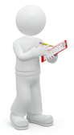
Before leaving the premises for the night, it is usual to check the venue to see if anyone is trying to get themselves locked in.
Many thieves prefer being locked in and then having to break out, rather than having to break in.
Areas to check include:
- Toilets – male, female and disabled
- Store rooms
- Behind curtains
- Behind alcoves
- Any areas open to the public.

4.2 Clear, clean or dismantle bar areas in accordance with enterprise procedures

Introduction
In all bar closing procedures there will be a need for some items to be cleared, cleaned or dismantled in preparation for the next shift or day of trade.
This Section identifies what is involved in these processes.

Clearing, cleaning and dismantling – defined
Clearing includes removing items – such as taking items off tables, from displays and from waiting stations and bar counters.
Cleaning is the removal of visible debris from food and beverage preparation items and equipment – such as cleaning of drip trays, cleaning of bar counters and cleaning of jugs, knives, glasses etc.
Dismantling of items involves the taking apart (and sometimes, also, the re-assembly of) espresso machines, post-mix machines, blenders and other items of equipment used in the preparation of and service of drinks.

Closing procedures
Bar closing procedures are all the tasks needed to be done in order to shut the bar after service so it is ready to open for service the next day or shift.
Bar closing procedures are essentially variations on a theme, and will vary between establishment depending on the size of the bar, the nature of the bar, staff numbers and sometimes the level of trade and/or day of the week.
Some establishments allow and encourage staff to commence closing down the bar operations near the end of the shift, while customers are still occupying the premises.
Other venues insist closing down commences only after all patrons have left, and the bar is closed.
Whatever the case, you must work in accordance with establishment requirements (and with minimal disruption to the customers and operations if applicable).

What duties are involved?
Closing procedures may include:
- Disconnecting the draught beer – turning off beer chillers (where applicable) and running water through the lines and leaving lines wet or dry depending on house policy: beer dispensed from the lines must be thrown out as it falls under the definition of ‘waste beer’
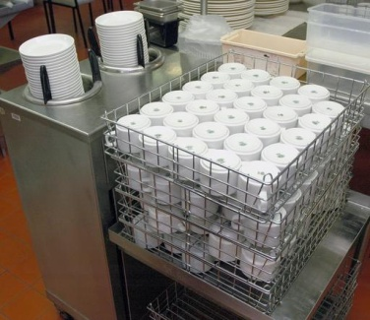
- Washing the drip trays from under beer fonts, post-mix units, espresso machines and glass racks, and allowing to air dry
- Cleaning all dirty glassware and storing them in appropriate places – pay attention to ensure all glasses are washed and cleaned properly and remove any chipped or broken glassware from service
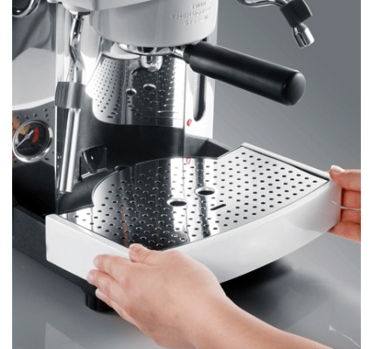
- Checking stock levels of all beverage items including beer, wine, spirits, liqueurs, mixers, bottled water, milk, cream, fruit juices, and re-ordering as necessary
- Collecting all dirty bar runners, tea towels, swabs and cloths and placing them in the laundry – in some venues you may be required to place them in a washing machine and start the wash cycle
- Discarding all used and soiled coasters – keeping suitable ones for next service
- Collecting and washing all ashtrays – ashtrays should not be washed in the glass washing machine
- Checking all equipment and bar utensils are clean and in good working order – this includes completing necessary documentation (such as ‘Maintenance Request’ forms), or verbally notifying the supervisor of anything you believe needs attention
- Placing appropriate spirit pourers into soda water to soak overnight – place ouzo pourer into a separate container to soak: always follow house policies in this regard
- Covering all garnishes and perishable items and storing under refrigeration – throw out items as necessary
- Cleaning, drying and stacking service trays
- Emptying and cleaning ice buckets
- Turning off, dismantling and cleaning espresso coffee machine – always follow manufacturer’s instructions
- Removing all rubbish from bar areas and cleaning the internal rubbish bins
- Emptying the empty-bottle bin/s – note attention should be paid to the noise dumping empty bottles into a bin makes at night time/early morning: venues may receive complaints from in-house guests and local residents if they make a noise when emptying bottles into bins at night/early morning so many venues do this job the following day as part of the cleaners’ duties
- Cleaning all surfaces
- Sweeping and mopping the floor – unless these jobs are done by cleaning staff
- Counting and reconciling the takings and transporting same to a central secure area
- Checking to ensure the bar is presentable and ready for the next service.

Scope of responsibilities for different workers
In relation to dismantling and or maintaining the operating condition of bar equipment, most staff will have responsibility for:
- Following manufacturer’s instructions – in the use, dismantling, cleaning and maintenance of bar equipment
- Adhering to all workplace cleaning schedules – including applying all given cleaning instructions as they apply to chemicals to be used and cleaning items (equipment, cloths, swabs) to be used
- Conducting daily checks on equipment – to verify they are working properly and to identify need for maintenance or service: this is done on an on-going basis throughout the day as items are used, and is always undertaken at the end of the day when regular cleaning and closing down procedures are being done
- Reporting any equipment not operating correctly – report it immediately to your supervisor.

4.3 Store garnishes and accompaniments, correctly

Introduction
At the end of trade all garnishes and accompaniments must be stored correctly.
This Section looks at options for achieving this requirement.

Garnishes
The storage of garnishes varies greatly.
Because of this great variation, you must check your house policy to determine what they see as ‘correct’ storage.
Some premises store all unused garnishes so they can be used during the next session, while others throw out everything left over.

What may be involved?
Where your premises elects to store unused garnishes, it is also likely they will choose to store other left-overs such as:
- Opened bottles of soft drink which they re-seal – most premises do not store open cans of drink
- Fresh fruit juice squeezed on the premises
- Sour mix – for use in cocktails
- Sugar syrup – an ingredient in sour mix and in some cocktails.

How are they stored?
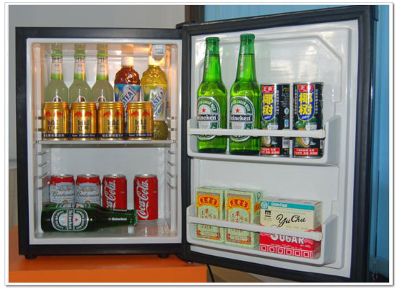
The basic options are:
- Using a bottle seal to re-seal bottles prior to storing them under refrigeration
- Covering jugs of fruit juice, sour mix and/or sugar syrup with plastic wrap and then refrigerating
- Covering slices of lemon, orange and lime with (soda) water and refrigerating them – an alternative is to just cover them with plastic film and refrigerate
- Maraschino cherries should be replaced in their original bottle/jar, sealed and refrigerated.
Even though garnishes are not high risk foods, the typical units they will be stored in should ensure their temperature stays below 5ºC and, thus, out of the Temperature Danger Zone.
All garnishes being handled for storage purposes should be handled with tongs (or some similar utensil) or clean gloves.
It is standard procedure to keep all the garnishes:
- Covered – to prevent contamination
- Separate – to avoid colour and/or flavour mix/bleed.

Accompaniments
The storage of accompaniments (drinking straws, drink decorations) is comparatively straight-forward.
They are either:
- Covered and left where they are – behind or on the bar
- Covered and moved to a cupboard or other storage area in the bar.

4.4 Set up bar for next service

Introduction
At the end of trade, staff traditionally undertake some preparation for the next shift or day by setting up the bar ready for the next session.
The general requirement is you should leave the bar in the state you would like/expect to find it when starting work yourself.
This Section describes the set-up duties which may be required to prepare the bar for the next session.

The basics of setting up for the next day
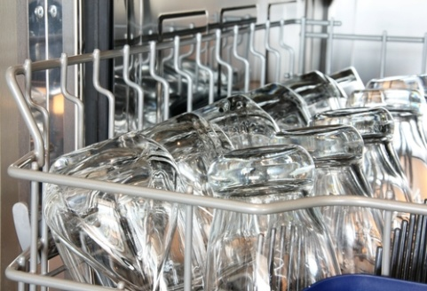
Setting up for the next day involves:
- Washing and putting away all glassware – all glasses should go into their own individual trays/holders: there should never be a mixture of glass sizes/types in the one tray
- Fresh bar linen may be stacked behind the bar – ready for the next shift to use or lay out
- Any available stock must be stored away – this especially applies to items needing to be served refrigerated
- Staff communication book to be completed where necessary – to advise incoming shift regarding any issues they need to be aware of
- Complete necessary ‘Maintenance Request’ forms – to initiate required repairs or service for bar equipment
- Cleaning, cleaning, cleaning – this is an important consideration in all bars and includes ensuring behind the bar and ‘the customer’s side’ of the bar is clean: cleaning must include tasks appropriate to the type of bar, the bar facilities and the level of mess, but can be seen to include:
- Picking up papers, debris and litter
- Sweeping and mopping
- Washing down and drying surfaces
- Putting items away/into their correct place
- Taking out rubbish and empty bottles and cans
- Moving tables and chairs to facilitate the work to be done by the cleaners.

Variations to the standard bar set up practices
The standard set up procedure for bars will vary when special occasions dictate a departure from what has proved to be an effective routine.
Examples of such occasions include times when on the following day there is:

- A public holiday – management may want staff to do extra work on the day prior to the public holiday because the pay rate is cheaper and there is a need to be well-prepared
- A special promotion expected to attract large numbers – to ensure sufficient stock, equipment, glasses etc are available to cater for the increased, expected numbers
- Any staff absence known about in advance – to ease the pressure on tomorrow’s staff
- A large booking – to make sure all special requests have been accommodated and all possible preparations have been done to optimise the chances of a successful function
- A special day (event, celebration, public holiday) – to put the final touches to themed displays, advertised events or special occasions
- Special servicing, maintenance or cleaning of facilities or equipment – from time-to-time there will be a need to accommodate major events such as carpet cleaning, programmed maintenance services, major repairs
- Arrival and installation of new equipment into the bar area.

4.5 Handover bar, where appropriate, to incoming bar staff

Introduction
A handover is a situation where the bar remains open but the staff behind the bar change.
While it is uncommon – and often inadvisable – for all the staff to change at the same time when there is a handover (it is best if there is some continuity of staff), this situation can sometimes occur especially where there is only one staff member running the bar.
This Section describes what needs to be taken into account at handover.

Things to ensure when conducting a handover
When handing over a bar to another staff member or group of staff, it is important to ensure:
- The bar is clean and in good order – as mentioned previously, the out-going staff member should try to leave the bar (as far as is possible given the level of trade) in the condition they would like to find it. This means they should do some cleaning before the new staff arrive, as opposed to leaving the bar dirty and just walking out at knock off time
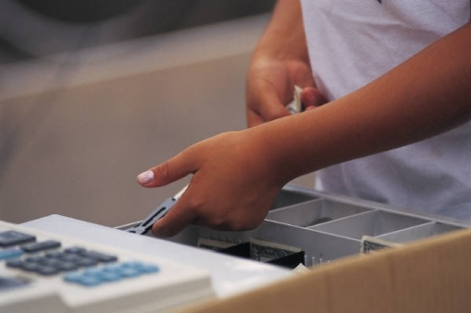
- Change in the cash register is sufficient for the next shift – and necessary change has been ordered and obtained, where necessary
- Information about particular customers in the bar is passed on – special attention must be paid to those who have already been spoken to or caused trouble or who appear to be intoxicated
- Information about customer complaints and operational problems is passed on – covering all relevant details
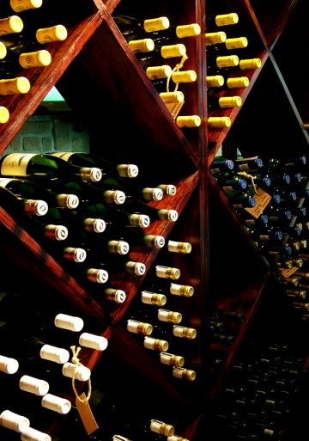
- Customer orders are addressed – if there is a customer order which has been taken but not filled this must be communicated to in-coming staff
- Customer preferences are passed on – if a certain customer is drinking a certain brand of spirits, beer or wine this should be shared with staff who will be serving that customer
- The bar is as well-stocked as possible – this may necessitate obtaining more stock to allow the next shift to trade as expected.
Before departing after making a handover, check all is running smoothly and verify your services are no longer needed.
It is not acceptable practice to simply walk out of the bar when the clock reaches your knock-off time.

Work Projects
It is a requirement of this Unit you complete Work Projects as advised by your Trainer. You must submit documentation, suitable evidence or other relevant proof of completion of the project to your Trainer by the agreed date.
4.1 Provide a demonstration in (or submit video evidence of) a real-life or simulated situation which provides proof you can:
- Turn off necessary bar equipment at the end of trade
- Clean, clear and/or dismantle bar equipment and the bar area as required as part of bar closing procedures
- Set up the bar for the next trading session.
4.2. Provide a demonstration in (or submit video evidence of) a real-life or simulated situation which provides proof you can:
- Conduct an effective handover of a bar leaving the bar as it should be and communicating all necessary information and issues to incoming staff.

Summary

Close down bar operations
When closing down bar operations:
Turn off nominated equipment
Turn off nominated equipment
Conduct internal security checks
Activate alarms as required
Clean. clear and dismantle equipment as required
Implement all established closing procedures
Store garnishes and left-over bottles if/as required
Protect and store other stock and decorations
Set up bar for next service
Order stock if required
Perform handover in accordance with bar protocols.

Presentation of written work

1. Introduction
It is important for students to present carefully prepared written work. Written presentation in industry must be professional in appearance and accurate in content. If students develop good writing skills whilst studying, they are able to easily transfer those skills to the workplace.

2. Style
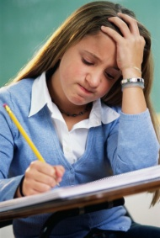
Students should write in a style that is simple and concise. Short sentences and paragraphs are easier to read and understand. It helps to write a plan and at least one draft of the written work so that the final product will be well organized. The points presented will then follow a logical sequence and be relevant. Students should frequently refer to the question asked, to keep ‘on track’. Teachers recognize and are critical of work that does not answer the question, or is ‘padded’ with irrelevant material. In summary, remember to:
- Plan ahead
- Be clear and concise
- Answer the question
- Proofread the final draft.

3. Presenting Written Work
Types of written work
Students may be asked to write:
- Short and long reports
- Essays
- Records of interviews
- Questionnaires
- Business letters
- Resumes.
Format
All written work should be presented on A4 paper, single-sided with a left-hand margin. If work is word-processed, one-and-a-half or double spacing should be used. Handwritten work must be legible and should also be well spaced to allow for ease of reading. New paragraphs should not be indented but should be separated by a space. Pages must be numbered. If headings are also to be numbered, students should use a logical and sequential system of numbering.
Cover Sheet
All written work should be submitted with a cover sheet stapled to the front that contains:
- The student’s name and student number
- The name of the class/unit
- The due date of the work
- The title of the work
- The teacher’s name
- A signed declaration that the work does not involve plagiarism.
Keeping a Copy
Students must keep a copy of the written work in case it is lost. This rarely happens but it can be disastrous if a copy has not been kept.
Inclusive language
This means language that includes every section of the population. For instance, if a student were to write ‘A nurse is responsible for the patients in her care at all times’ it would be implying that all nurses are female and would be excluding male nurses.
Examples of appropriate language are shown on the right:
Mankind | Humankind
Barman/maid | Bar attendant
Host/hostess | Host
Waiter/waitress | Waiter or waiting staff

Recommended reading
Australian Training Products Ltd 2004; Professional Bar Supporting THH02 Hospitality Training Package; Version 1.00, Australian Training Products, Melbourne, VIC.
Colvin, Geoff & Battistella, Peter 2007; The successful Bartender: Putting People Skills to Work; Behavior Associates, Eugene, Or
Feller, Robyn M 2003; The Complete Bartender; Rev. Berkley trade pbk. Ed, Berkley Books, New York
Foley, Ray & Dismore, Heather 2011; Running a Bar for Dummies; John Wiley & Sons, Inc, Hoboken
Hazel, Roger & Prinzhorn, Brigitte & Snowdon, Tina 2006; Bar Operations: A Procedures Guide; Chantillybah Pub, Gold Coast, Qld
Katsigris, Costas & Thomas, Chris, 1956 – 2012; The Bar & Beverage Book; 5th Ed, John Wiley & Sons, Hoboken, N.J
Miron, Amanda & Brown, Douglas Robert, 1960 – 2006; The Professional Bar & Beverage Manager's Handbook: How to Open and Operate a Financially Successful Bar, Tavern, and Nightclub; Atlantic Pub. Group, Ocala, Fla
SmallPrint Australia 2008; Tourism, Hospitality and Events Training. SITHFAB002A, Operate a Bar: Participant Notes and Workbook; Version VC6, smallPRINT, [Australia]
Steabben, Russell & Corsar, Frank, 1954 – 2005; The Australian Bartender's Guide to Cocktails; 5th Ed, Pearson Education Australia, Frenchs Forest, N.S.W
United Kingdom Bartenders' Guild 2006; The International Guide to Drinks; Rev. and updated ed, Ebury, London

Trainee evaluation sheet

Operate a bar facility
The following statements are about the competency you have just completed.
Please tick the appropriate box | Agree | Don’t Know | Do Not Agree | Does Not Apply
There was too much in this competency to cover without rushing.
Most of the competency seemed relevant to me.
The competency was at the right level for me.
I got enough help from my trainer.
The amount of activities was sufficient.
The competency allowed me to use my own initiative.
My training was well-organised.
My trainer had time to answer my questions.
I understood how I was going to be assessed.
I was given enough time to practice.
My trainer feedback was useful.
Enough equipment was available and it worked well.
The activities were too hard for me.

The best things about this unit were:

The worst things about this unit were:

The things you should change in this unit are:

Trainee self-assessment checklist
As an indicator to your Trainer/Assessor of your readiness for assessment in this unit please complete the following and hand to your Trainer/Assessor.

Operate a bar facility
 |  | Yes | No*
Element 1: Prepare bar for service
1.1 | Set up bar display and work area in accordance with enterprise requirements
1.2 | Check and restock bar products and materials where necessary in accordance with enterprise requirements
1.3 | Ensure service equipment is clean, operational and ready for use
1.4 | Store items in the correct place at the correct temperature
1.5 | Prepare and stock a suitable range of garnishes and accompaniments
Element 2: Take drink orders
2.1 | Receive customer orders
2.2 | Check product and/or brand preferences with customer in a courteous manner
2.3 | Provide clear and helpful recommendations or information to customers on selection of drinks if required
Element 3: Prepare and serve drinks
3.1 | Greet customers in a polite, friendly and helpful manner
3.2 | Prepare drinks in accordance with legal and enterprise standards using the correct equipment, ingredients and measures
3.3 | Serve drinks promptly and courteously
3.4 | Handle and use industry standard glassware and use garnishes and accompaniments appropriately
3.5 | Minimise spillage and wastage and attend to accidents during service promptly and safely
3.6 | Seek assistance from appropriate people for situations which pose a threat to safety or security of colleagues, customers or property
3.7 | Seek feedback from customers in order to identify and implement improvements to beverage quality and take appropriate corrective action, if required
3.8 | Deal with unexpected situations in accordance with enterprise procedures
Element 4: Close down bar operations
4.1 | Turn off equipment in accordance with enterprise safety procedures and manufacturer’s instructions
4.2 | Clear, clean or dismantle bar areas in accordance with enterprise procedures
4.3 | Store garnishes and accompaniments, correctly
4.4 | Set up bar for next service
4.5 | Handover bar, where appropriate, to incoming bar staff

Statement by Trainee:
I believe I am ready to be assessed on the following as indicated above:
Signed: _____________________________ | Date: ____________

Note:
For all boxes where a No* is ticked, please provide details of the extra steps or work you need to do to become ready for assessment.





